Strengthening Our Villages

Stronger Families Alliance
Child, Youth and Family Strategy

2019 – 2024

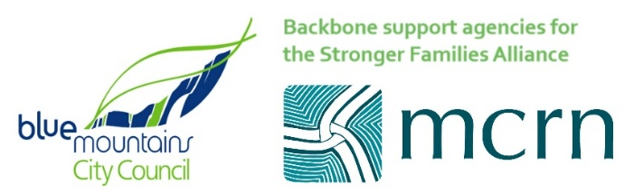
Acknowledgement of Ngurra (Country)
The City of the Blue Mountains is located with the Ngurra (Country) of the Darug and Gundungurra peoples. Blue Mountains City Council recognises that Darug and Gundungurra Traditional Owners have a continuous and deep connection to their Ngurra and that this is of great cultural significance to Aboriginal people, both locally and in the region.
For Darug and Gundungurra people, Ngurra takes in everything within the physical, cultural and spiritual landscape—landforms, waters, air, trees, rocks, plants, animals, foods, medicines, minerals, stories and special places. It includes cultural practice, kinship, knowledge, songs, stories and art, as well as spiritual beings and people—past, present and future.
Blue Mountains City Council pays respect to Elders past and present, while recognising the strength, capacity and resilience of past and present Aboriginal and Torres Strait Islander people in the Blue Mountains region.
Gundungurra Indigenous Land Use Agreement (ILUA)
The Gundungurra ILUA is an Agreement between the Gundungurra people and the NSW Government. Blue Mountains City Council acknowledges this ILUA and supports the Gundungurra achieve their aspirations through the ILUA by way of advice and initiatives from Council’s Aboriginal Advisory Committee.
The Gundungurra ILUA broadly covers lands and waters of the southern half of the Blue Mountains LGA extending to the Southern Highlands, and including all the townships in these two regions.The ILUA acknowledges the Traditional Ownership by the Gundungurra of the country within these borders and highlights their aspirations for cultural maintenance and economic and social self-determination. As such, the Gundungurra ILUA provides the framework for Council and its partners in the community sector and other levels of Government to understand and work in a culturally appropriate and respectful way with the Gundungurra Traditional Owners. In developing and implementing actions for this Strategic Plan, Council and the Stronger Families Alliance will seek to ensure that the processes for decision-making respond to the protocols for appropriate engagement of the Gundungurra and Darug Traditional Aboriginal Owners of the lands and waters of the Blue Mountains.
Vision
Children and young people in the Blue Mountains are provided with opportunities to thrive and reach their full potential.

In recognition of the Blue Mountains’ World Heritage significance and its social and cultural richness, children and young people are nurtured to become engaged and responsible citizens socially, emotionally, culturally, environmentally and economically.

Parents and carers have the opportunity to participate and make a positive contribution to community life.

The Stronger Families Alliance is  - A network of Blue Mountains organisations, groups and individuals  - committed to collaborative action through a Collective Impact approach  - Supported by Blue Mountains City Council and the Mountains Community Resource Network as “Backbone” organisations  - Directed by Main Group of Alliance members and supported by an Executive  working to improve outcomes and opportunities for children, young people and their Parents/Carers in the Blue Mountains | Timeline  - 2006: Formation  - 2010: Produced first Plan  - 2014: Expanded to include young people (12- 18) and focus on resilience and wellbeing  - 2015: Adoption of Collective Impact Approach  - 2016: Adoption of Ultimate Outcomes  - 2017: Began Shared Measurement Project  - 2019: Implementation Strategy
What is the Stronger Families Alliance?
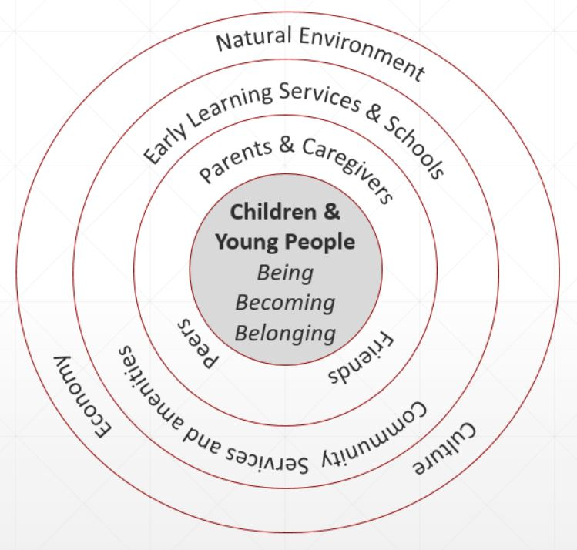
Our Goal
Our goal is to promote the wellbeing and resilience of children and young people in the Blue Mountains by progressing the Ultimate Outcomes
Being | Children and young people are safe, healthy, flourishing and have a secure cultural identity.
Belonging | Children and young people feel they belong to the community and the place where they live.
Becoming | Children and young people reach their full potential.
We also aim to assist those who support children and young people - families, early learning providers and schools and community members - to nurture child and youth mental health and wellbeing.
Caring | Parents, caregivers and families care for and support their children to reach their full potential
 | Early Childhood Education Services (ECES), schools and community sector organisations support children and young people to flourish and learn
 | The Blue Mountains community provides a safe, caring and supportive environment for children and young people to live
We seek to do that by working together as effectively as we can.
Supporting | Stronger Family Alliance services work together to support the above outcomes

Children and Young people are at the Centre of our Work
How We Are Structured
Resilient Children and Young People
Children Start School Ready to Learn
Child and Youth Friendly City
Confident Parents, Engaged in their children’s learning
Back Bone
Develop the Alliance:
- Facilitate the collaborative network
- Drive sector and Alliance communication
- Evaluation of the Child and Family Plan
- Professional development
- Convene Main Group and Executive meetings
- Research and data management
- Telling the story of the Alliance to the community
MAIN GROUP
Support the implementation of the Child and Family Plan
- Maintain whole system common vision
- Set / sign off on Implementation Group core directions and major initiatives
- Facilitate cross-implementation Group synergies, opportunities, learning and innovation
- Respond to evaluation information
- Identify needed Alliance capacity building initiatives
Implementation Groups: Implement the Child, Youth and Family Plan
- Set implementation directions or carry out implementation directions decided by the Main Group
- Develop and implement initiatives
- Review the success of initiatives to determine what works, communicate this.
- Maintain strategic line of sight between initiatives and the Child and Family Plan
- Community education about the Plan
- Source resource and funding for initiatives.
EXECUTIVE
Care-taker of the Alliance and Child and Family Strategy
- Ensure the Alliance’s long term sustainability by considering the external environment and long-term future
- Keep the implementation groups strategically on track (including oversight of the Strategy’s development)
- Manage political interface
- Source and manage external partnerships
- Link to the Backbone
- Determine funding directions
- Sign off on Evaluation plan.
How do we work: Collective Impact Model
Collective Impact Elements
The Collective Impact Model identifies 5 elements underpinning successful collective ventures
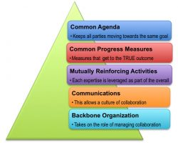
- A common agenda for change including a shared understanding of the problem
- Collecting data and measuring results consistently across all the participants
- A plan of action that identifies mutually reinforcing activities for each participant.
- Open and continuous communication across the many players
- A backbone organisation(s) with staff and specific set of skills to coordinate the entire initiative

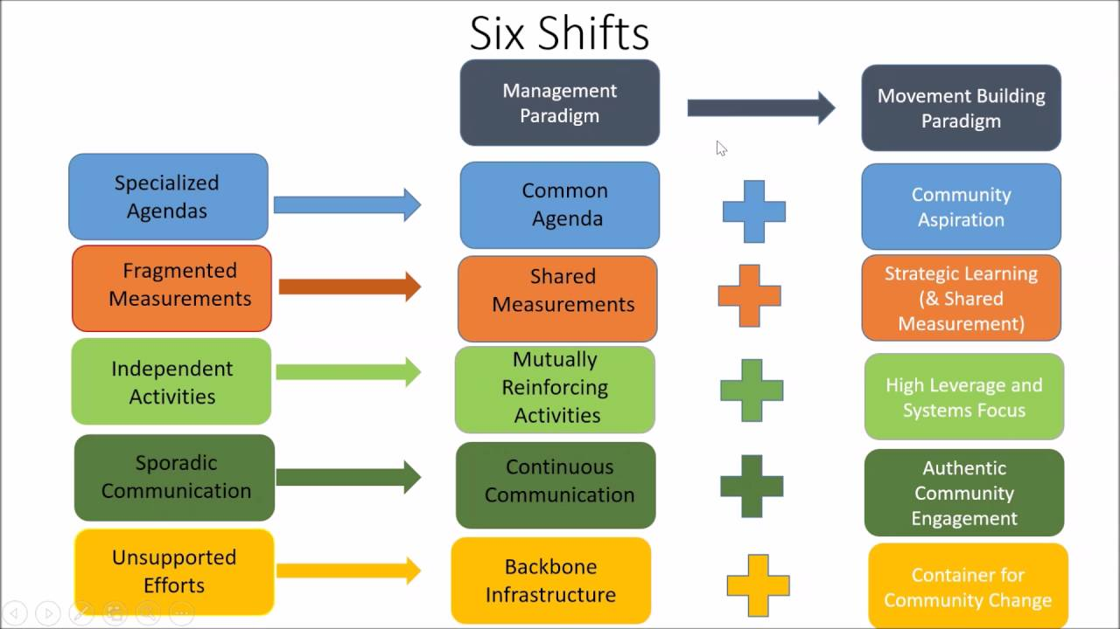
How do we work: Collective Impact Model: Mark II
Collective Impact Changes
The adjacent diagram illustrates recent changes, or “shifts” in the Collective Impact approach. Column 1 represents how work was conducted prior to Collective Impact. Column 2 is the first iteration of Collective Impact and Column 3 represents its development over time.
The Shifts that are most relevant to the Alliance and this Child, Youth and Family Plan, are from
- Shared Measurement to Strategic Learning. The implementation of the Shared Measurement and Action Planning strategy proved difficult and complex for many in the Alliance, in the context of time and capacity constraints. A Strategic Learning approach, which does not require the same degree of consistency and commitment to measurement techniques, may better serve this Plan's Objectives.
- Continuous Communication to Authentic Community Engagement. The predominance of agency representatives in the Alliance membership, rather than resident / community representation, has meant that Continuous Communication has been largely between agencies. As a result, the Alliance is identified as an interagency project, rather than a community participatory project.

Australian Collective Impact Projects - Learnings
In addition to the shifts identified in the international literature on Collective Impact, a national analysis of Collective Impact projects in Australia has emphasised three issues:
- community engagement,
- equity and
- capacity to deliver systemic change
As a consequence of this evolution and Australian project analysis, addressing these three issues is a priority in the development of framework, monitoring and evaluation of this Plan. For a detailed discussion on the Alliance's use of the Collective Impact approach, including these shifts in conception and priorities, see Appendix 1.
SEIFA Map and Key Population Indicators
Key population indicators | Metrics | Source
Total population (Greater Sydney 22.1%) | 22.2% | Census 2016
Population 0 – 4 years (Greater Sydney 6.4%) | 5.5% | Census 2016
Population 5 – 17 years (Greater Sydney 15.7%) | 16.7% | Census 2016
Vulnerable on 2 or more domains when start school | 7.5% | AEDC 2015
15 – 19 years participating in study or work |  | Census 2016
Average school attendance
15 – 24 years participating in study or FT/PT work | 86.9% | Census 2016
15 – 24 years participating in FT or PT work
…School completion rates | 76% | Census 2016
…Children and young people with disabilities
…Numbers of ATSI children and young people | 778 or 43% | Census 2016
…Numbers of refugee children and young people
…Resilience and Wellbeing survey (compare with Vic and Sydney results)
Numbers of disengaged young people 16-24 |  | Census 2016

What have we learnt so far
- Difficulty of doing Collaboration – gap of intention and reality
  - Collaboration is challenging: it requires resources, trust, time, and motivation
  - Organisations are required to move from an output based framework to an impact based framework
  - In a climate of competitive tendering and turf claiming, organisations may be unwilling to collaborate unless they see a direct benefit to their organisation
  - Embedding Alliance activities into member organisations is needed to build systemic, long term outcomes, but is difficult due to the issues above
- Shared Measurement challenges
  - Difficulty in choosing, or being able to access, the right indicators
  - Making sense of data and establishing a coherent sense-making framework
  - Understanding how each member contributes to shared measurement
  - Time and capacity limitations of member agencies
  - Getting bogged in data and fragments of the story rather than what is being learned and understood
- Impact of the Funding Environment
  - Reform of the funding program and changed relationships with funding agencies has resulting in extended periods of uncertainty, and consequent stalling of implementation of initiatives
  - The right conditions have to be present at the organisational and sector level for effective collaboration to occur, especially the policy support for collaboration and new initiative development, rather than the focus just on individual outcomes in core service delivery areas
  - “Early intervention” framed around narrow understanding of highest individual need, at the expense of inclusive community level strategies
- Capacity of members to do the work
  - Organisations constrained by individual contracts and KPIs may not have the capacity or appetite for collaboration.
  - This will only change when collaboration is written into the funding agreements of organisations, and
  - When funders understand that individual organisations can’t effect population level impact on their own.
- Ownership and Leadership
  - Need to build leadership amongst the membership (rather than being held by the Backbone)
  - Ensure action is steeped in a sound understanding of the political context that gives rise to inequity and vulnerability
  - Broadening theoretical knowledge in community development and coalition building.
- Community engagement challenges
  - The framing and structuring of Collective Impact Collaboration in the Alliance has not been resident friendly: i.e. meeting times and format; background theory; time to undertake engagement.
  - Harwood consultations offer the opportunity to build upon surveying engagement to participatory engagement
More detailed discussion on learnings for the Alliance on collaboration and Collective Impact are in Appendix 1.

About this Strategy
Guided by the Vision adopted by the Alliance and Council (see above ) the following Objectives and Outcomes have been identified for the implementation of this Plan:

Objectives
To achieve the above Vision, this Plan will identify and develop a series of Projects for Children, Young People, Parents and the City:
- that can deliver measurable benefits to children and young people and families, particularly to those who may be vulnerable or marginalised. Benefits will be in terms of the broad Outcomes described below, and relevant to the specific needs and opportunities of the Blue Mountains
- that utilise the participation of Blue Mountains’ residents, particularly communities of interest with strengths and skills
- in collaboration with relevant Blue Mountains’ agencies
- that can lead to systemic change within Council and community agency partners
- that are informed by research and analysis of community need, opportunity and evidence-based practice

Outcomes for Children, Young People and Families
A theoretical and practical analysis of best practice in the support for children and young people, and the measurement of outcomes of interventions, was developed by Consultancy for the Alliance in 2017. The Alliance adopted 8 Outcomes for children and young people (see above) along with a commitment to “Shared Measurement”, using robust and widely accepted indicators to measure results against these outcomes.
These Outcomes have informed this Plan, with the addition of a 9th Outcome, relating to parents and carers. This 9th Outcome is included in recognition that the participation of parents and carers to community life should be an outcome in itself, and that inter-generational factors (i.e. inter-generational disadvantage, education levels, social / economic connections, etc) have a bearing on outcomes for children and young people.
___________________________________________________________________
- Children meet their holistic developmental milestones.
- Children have secure and nurturing relationships with their family, friends and the community.
- Children and young people have equitable access to the resources they need to reach their full potential.
- Children and young people are safe, healthy, flourishing and secure in their cultural identify.
- Children and young people feel valued by the community and have positive participatory connections with family, friends, community and the place where they live.
- Children and young people contribute to others, the community, the place where they live and the environment.
- Children and young people engage in education and have developmentally appropriate self-regulation and life skills.
- Young people are well connected with post school pathways to quality education and / or employment.
- Parents and Carers participate and make a positive contribution to community life, including to the local economy, culture, recreation opportunities and access to natural environments.

Methodology
Iterative Local Project Development
The development of the Methodology for the work of the Alliance in achieving the Vision, was strongly influenced by the three factors discussed above, namely:
- The Ultimate Outcomes and Objectives.
- The evolution of Collective Impact approach
- What we have learnt so far
Consideration of these commitments and issues emphasised that a Methodology needed to be flexible and responsive, in terms of participation, activities undertaken, timeframes and regular review. Setting a series of projects, to be undertaken and resourced by identified agencies over the course at the Plan, would be both unrealistic and counter- productive to the process of Strategic Learning anticipated to deliver the best outcomes.
As a result the Implementation methodology has taken the form of iterative project development, where initial, short-term projects are initiated and implemented, and outcomes from these to inform subsequent work. However, this iterative project development process will be in a framework comprising four consistent Focus Areas
- Children
- Young People
- Parents & Carers and
- The City.
The intention of this Focus is that at any one time there would be a project operating in each of these Focus Areas, therefore comprehensively addressing the Vision and Outcomes of the Alliance.
This iterative approach is also intended to assist in securing resident participation in the work of the Alliance. Securing community participation has been identified as a challenge for Collective Impact projects, and for the Stronger Families Alliance itself, as outlined below.

Principles
The five principles that frame the methodology for this Strategy are
- Measurable Outcomes for Children Young People and Families (as described above)
- Locally Developed Projects addressing Locally Identified Priorities
- Community Development Approach
- Knowledge, Social Research and Evidence-based Practice
- Monitoring and Evaluation

- Measurable Outcomes for Children, Young People and Families
The above Outcomes framework was developed through systematic analysis, using the expertise of Alliance members and informed by exhaustive research commissioned by Council . The Backbone agencies and the Alliance membership are confident the Framework is a robust analysis of real and significant Outcomes for children, young people and families and will secure wide community support.
However, these 9 Outcomes are broad and generic, relevant to all children, young people and families, regardless of where they live. The focus and content of Projects developed under this Strategic Plan will be specific to the needs and opportunities for children, young people and families in the Blue Mountains. The Alliance will evaluate these projects according to their effectiveness in achieving their project goals and their measurable benefits under these 9 Outcomes.
- Locally Developed Projects addressing Locally Identified Priorities
Through this Strategic Plan a series of discrete, local-level projects will be developed that address specific, locally relevant priority needs or opportunities for children, young people and families that relate to one or more of the 9 Outcomes. Locally relevant Priorities are identified through:
  - Demographic research and data collection on the Blue Mountains population characteristics. This is collected by the Backbone, principally the Council Social Research and Data Management position, which was created partly to support the Alliance, but also occasionally by community sector partners (see below).
  - Longitudinal data collection from residents on key issues relevant to the wellbeing of children, young people and families. Council has begun longitudinal data collection on Resilience and Wellbeing of Blue Mountains’ residents, particularly children and young people, developed in consultation with community sector partners, government departments and Council. The method uses two scientifically validated tools: The Personal Wellbeing Index and The Connor-Davidson Resilience Scale. The initial survey was conducted at Secondary Schools in 2018 throughout the Blue Mountains and through the Have Your Say online platform. The data will provide a baseline to identify the efficacy of the Alliance’s Priority areas and Implementation Strategies, and other work of Council, alongside other measurement tools.
  - Consultation, surveying and community engagement. A key consultation and engagement tool relevant to this Strategy is the use of the Harwood Methodology for surveying known as “ Harwood Asks”, and for eliciting more detailed information in “Harwood Conversations". Alliance members have developed expertise in the Harwood Methodology over a number of years. This information collection is also augmented by other tools and avenues for consultation provided by the Backbone agencies, including Council’s the Have Your Say survey, Social Research workshops and focus groups, public exhibitions, and MCRN’s and other Alliance members data collection on community issues and service delivery. Priorities for children and young people identified in Harwood consultations conducted In 2015 and 2016 include:
          - The Environment
          - Safety
          - Living in a friendly, accepting, respectful and welcoming community
          - Mental Health and well-being
In addition to these priorities, the Stronger Families Alliance identified a further priority based upon data collected for children in the Blue Mountains and their own experience:
          - Children's early development and health.
  - The experience and expertise of workers and management of the Alliance membership and other community agencies. There is a very significant pool of expertise and cooperation amongst the community sector which the Alliance facilitates project initiation, development and collaboration.?
As mentioned above, new project development will be an iterative process that reviews progress of projects, engages with residents and partner agencies and develops further projects building upon the previous achievements, or moving to new challenges with increased participation.
- Community Development Approach
Community Development is a concept that has a long history and an evolution, and consequently has different meanings to different people. The United Nations describes community development as "a process where community members come together to take collective action and generate solutions to common problems." (United Nations "Community development".)
The Alliance broad membership and the Backbone agencies (MCRN and Blue Mountains City Council) support a Community Development approach, although these may be framed in slightly different ways. During 2017, Council revised its Community Development Strategy, including a definition, which the Alliance is CONSIDERING FOR ADOPTION, namely that Community Development incorporates the key elements of
- Collective activity – which brings diverse expertise and perspectives, promotes “buy-in” by affected people and facilitates individual growth in the process of project implementation
- The involvement of communities of interest and/or communities of place – who bring sustained commitment, expertise and resources to the projects
- Activity for the common good – which promotes an altruistic culture and does not secure exclusive benefits for sectional interests, but has value for the wider community, beyond the direct beneficiaries
- Is not service delivery – but may establish or assist service development by community agencies
Accordingly, Community Development is defined as
“Collective Activity by Communities of Interest for the Common Good.”
- Knowledge, Social research and evidence-based practice
In order to gather, analyse and keep up-to-date knowledge of the Blue Mountains community, this Plan is supported by active and ongoing social research, coordinated by a designated position in Council's Community Development team: the Social Research and Data Management Officer. As indicated by this Position title, the management of social data is also a key support function for this Plan. "User friendly" presentation and dissemination of social data, along with the progress of Projects, is crucial for the Plan’s Projects to be supported by, and attract the participation of, the Blue Mountains community, including local agencies and all parts of Council.
The principle that an ''evidence base" can be identified to validate practices or activities developed for public benefit, has become established as an expectation by governments in their contracting of community agencies. In this context, in 2017 Council commissioned a consultancy to develop an evidence base for projects benefiting children, young people and families to be implemented through this Plan. This consultancy also involved facilitation of the development of “Shared Measurement” processes to be used by the Alliance, in accordance with of the Collective Impact framework.
Through the work of the Social Research and Data Management position, and the support of members of the Alliance or project partners within Council, the following activities will be implemented to measure and disseminate the effectiveness and community benefit of projects conducted under this Strategic Plan:
  - The collation and maintenance of up-to-date demographic data on key socio-economic parameters for children, young people and families in the various townships and/or planning areas (Upper, Middle and Lower).
  - research and analysis of specific social, cultural, economic or environmental issues, as identified by Alliance members from time to time, that are significant to the wellbeing and inclusion of children, young people and families. Key parameters for children and young people for this Plan are developmental milestones, relative geographic disadvantage and vulnerability.
  - identification and assessment of relevant evidence of effectiveness of project activities and requisite data collection to inform Evaluation of projects in this Plan
  - collate, present and disseminate, through various print, online and social media, key information secured through 1, 2, & 3 above, to as to enable Alliance members and the general community to assess the value of projects undertaken under this Plan
  - collect longitudinal data on Resilience and Wellbeing that can inform assessment of appropriateness of projects and activities
Basic demographic information on who lives where, is taken from the Census (see below: Where We are Now Appendix 2.), while specific issues and opportunities (i.e. mental health, mobility, safety etc) are identified through community consultations, analysis by partners to this Strategy, and in liaison with people in the community.
Particular emphasis is given to issues and opportunities identified by existing ''communities of interest" as these bring expertise and resources to any Projects developed.
The analysis provided by members of the Alliance is also given emphasis in this Plan, in recognition of the expertise within the Alliance membership and the systematic and collaborative processes used by the Alliance in prioritising issues.
- Monitoring and Evaluation
The Alliance Project partners will gather information on the achievement of identified milestones and make assessments of success and completion / continuation of Projects on a cycle of 18 months or 2 years. A format for the monitoring of Project milestones and success is provided in Appendix 3, however, Alliance members may use their own monitoring and evaluation practices rather than this template.
The Plan itself will be evaluated against its Objectives by the Backbone agencies at the 2nd and 4th years intervals. A full description of the Evaluation Plan is provided in the Evaluation Section below.
This Evaluation Plan has been informed by research into the performance of the Collective Impact approach in Australia, which identified, among other things three issues where improvements could be achieved:
  - Equity, in terms of outcomes for relatively disadvantaged / vulnerable people
  - Community engagement in the development and implementation of projects and
  - Systemic change that translates short-term project outcomes into long-term benefits for the intended participants and the community.
  - Equity
Relative disadvantage, or vulnerability, in members of the population is also recognised as warranting priority action. In identifying disadvantage/ vulnerability, this Strategy adopts the internationally recognised parameters for full participation in society and citizenship developed by the World Health Organisation in “The Solid Facts: The Social Determinants of Health”. The Solid Facts parameters of disadvantage/ vulnerability most relevant to the Blue Mountains population are
- Social Gradient | - Discrimination
- Stress | - Income and employment
- Early Life | - Social Safety networks
- Transport and Isolation | - Addiction
- Housing | - Disability
Accordingly, in developing and evaluating Projects under this Strategic Plan, benefits delivered to children, young people and families with be assessed with respect to people who may be disadvantaged / vulnerable, as defined by these parameters.

Membership of the Alliance comprises three major groups:
Alliance Members and their Roles

- Non government organisations funded by Family and Community Services, including (as at 2019)
  - Neighbourhood Centres
  - Mountains Outreach Community Service
  - Gateway Family Services
  - Thrive Services
  - Mountains Youth Services Team
  - Platform Youth Services
  - Connect Child and Family Services
  - Aboriginal Culture and Resource Centre
  - Blue Mountains Women’s Health and Resource Centre

- Government organisations:
  - Family and Community Services
  - Department of Education
  - Nepean Blue Mountains Local Health District

- Community partners, including (as at 2019)
  - Bendigo Bank
  - Rotary
  - The Big Fix
Members are partners in the Plan which speaks to and enhances their core business in addition to advancing the work of the Alliance. Membership of the Alliance entails participation in the Main Group.
Role of the Main Group
The Main Group makes all major decisions, and sets direction and vision. Main Group members have varying roles in their organisations. They approve all SFA initiatives and projects, though not all members are involved with projects.
The Main Group also is the forum for raising and discussing issues, formulating strategies, and developing implementation processes for Alliance actions.
Role of the Backbone
The Alliance backbone consists of Council and Mountains Community Resource Network. The backbone facilitates the collaborative network, ensures strategic alignment, and helps shape professional development for the sector. It has oversight of the writing and evaluation of the Plan and its Actions.
The Backbone convenes the Main Group and Executive, communicates the Alliance activity to the wider community and undertakes research and data management.
Mountains Community Resource Network - The Work of MCRN’s Team in implementing this Plan
Commitment of the Backbone Agencies to the Alliance

Blue Mountains City Council - The Work of Council’s Community Development Team in implementing this Strategy
The Community Development Team will coordinate Council's support for the implementation of this Plan and will look for opportunities for shared outcomes to be pursued with other teams in Council and with our range of community partners, some of which may not be a part of the Alliance.
The broad inclusiveness of “children, young people and families” means that work by the Community Development team with, and on behalf of, older people who are members of families, can be a part of the Alliance project. The role of grandparents and Elders may be particularly significant for families in the Blue Mountains.
While the framework for identifying benefit to children, young people and families developed through the Alliance is robust and appropriate, Council’s processes are not constrained by those of other members of the Alliance, and Council may have additional priorities for children, families and young people than those of the Alliance. The Strategy is embedded in Council’s core activities and reporting framework, as indicated in the diagram below.
Mountains Community Resource Network - The Work of MCRN’s Team in implementing this Plan (cont.)
State & Regional Plans
Community Strategic Plan
10 years+
Strategic Plans
Other Strategic Plans
Delivery Program
4 years

Operational Plan
1 year

Child, Youth and Family Strategy
Council’s Planning Framework

Details written in here

Where we want to be in the future
Children and Young People
The key elements of this Vision require that this Plan gives attention to children and young people
- reaching full potential
- being actively “engaged” in making contributions to
- society, the environment, the culture and economy.
This very broad vision for children and young people provides the scope for a diverse set of Projects, while emphasising the core or central concerns for active engagement, or participation, and opportunity to reach potential.
Parents and Carers
The Outcome relating to parents and carers recognises that inter-generational factors (i.e. inter-generational disadvantage, education levels, social / economic connections, etc) have a significant bearing on outcomes for children and young people. Inter-generational disadvantage is a widely acknowledged and researched phenomenon in Australia, notably in the work of Prof. Tony Vinson and colleagues. Also, the well-being of parents and carer's themselves, their needs and opportunities, warrant attention and support, where needed. The Alliance believes that a balanced family life is one where all family members have opportunities for participation in community life and individual fulfilment.

How we get there
Focus Areas to this Strategy
To achieve the Vision for the future outlined above, a series of discrete, local-level projects will be developed over the course of this Strategic Plan in each of 4 Focus Areas: Children, Young People, Parents and the City overall.
Projects underway as at January 2019, in each of the four Focus Areas, are described in Project Schedule and Monitoring below.
At the end of 2018/19 the Projects implemented well be evaluated and it will be determined whether to:
- continue to develop / deliver these projects and / or
- initiate new projects in each of the Focus Areas.
This iterative process of project development, implementation and review, will continue throughout the course of this Plan on an anticipated cycle of 18 months to 2 years. At the completion of the Plan period to 2024, the Strategic plan itself will be evaluated and assessments made by Council and the Alliance on a way forward to continue delivering benefits to children, young people and families in the Blue Mountains.

Project Schedule and Monitoring
At the beginning of the period of the Plan, only the first year's Projects are known. Subsequent to annual evaluation, these Projects may continue or may be replaced by different Projects.
It is intended that there be at least one Project for each Focus Area being implemented throughout the period of the Strategic Plan. Monitoring of the progress of individual Projects will be done by each Project team during the course of the Project. A template for Project monitoring is provided in Appendix 3, however Alliance members participating in Project delivery are free to use their own monitoring processes.

Focus Area 1: Children
YEARS | Alliance Projects | Council-only Projects - Informed by Alliance
2018- 2019 | Children Start School Ready to Learn
2019 -2020 | Children Start School Ready to Learn | Early Childhood Education Coordination (Engagement?) and Support Project
2020-2021
2021 -2022
2022-2023
2023-2024

Focus Area 2: Young People
YEARS | Alliance Projects | Council-only Projects - Informed by Alliance
2018-2019 | Young People Are Emotionally Resilient and do not Experience Anxiety or Depression
2019 -2020 | Young People Are Emotionally Resilient and do not Experience Anxiety or Depression | - Young People Harm Minimisation through Peer Support  - Grounded Permaculture Social Enterprise  - Blue Pen network: Implementing Positive Education at Schools  - Planet Youth (TBC)
2020-2021 |  | - Farm it Forward Social Enterprise  - Blue Pen network: Implementing Positive Education at Schools  - Planet Youth (TBC)
2021 -2022
2022-2023
2023-2024

Focus Area 3: Parents and Carers
YEARS | Alliance Projects | Council-only Projects - Informed by Alliance
2018-2019 | Parents are Confident and Engaged in their Children's learning and development
2019 -2020 | Parents are Confident and Engaged in their Children's learning and development | Grandparents Support project: research and recognition (TBC)
2020-2021 |  | Parents and Carers’ research (TBC?)
2021 -2022
2022-2023
2023-2024

Focus Area 4: The City
YEARS | Alliance Projects | Council-only Projects - Informed by Alliance
2018-2019 | Blue Mountains is a Child friendly City
2019 -2020 | Blue Mountains is a Child friendly City | Community Safety Strategy
2020-2021 |  | Play Strategy (is this appropriate to included here?)
2021 -2022
2022-2023
2023-2024

Implementation
Project Identification and Development
As outlined above, the approach taken in this Plan is aligned with the Ultimate Outcomes agreed by the Alliance and the evidence base for effective strategies, which are used to identify and assess projects as being worthwhile. Projects will be collaborative, tapping into existing expertise amongst Blue Mountains agencies and residents.
Implementation of the Plan will take the form of a series of local-level projects which further the 9 Outcomes for children, young people and families, as outlined above, and be
- developed and implemented with the participation of residents and local agencies, building upon their strengths and skills
- supported by evidence of effectiveness and community benefit
- temporal, designed to deliver identifiable and measurable outcomes at milestones and / or completion, and
- informed by the data and analysis secured through the social research described below.
To facilitate the development of these projects, the two Backbone agencies will actively establish and foster links with local agencies and resident participants who can contribute to these projects. Council's Community Development team will also engage with various branches of Council to identity and implement local projects that contribute to the Outcomes identified above.

Evaluation
Evaluation Methodology
The progress of this Strategic Plan will be Evaluated by the Backbone agencies at 2 years and at 4 yearly intervals, with respect to each of the Objectives. The key parameter through which these Objectives will be evaluated is How do we know the Objectives have been achieved or not, and how much or how little they have been achieved.
Also, evaluation will also be sensitive to any unanticipated benefits or deficits resulted from the implementation of Projects.This later parameter recognises that Projects developed through a Community Development approach, and involving collaboration between agencies and across different professional expertise, can (and often do) deliver outcomes that may not be anticipated in the Project design phase. It is important to identify and document these unanticipated outcomes as they can inform future decisions and partnerships.
Framework to Evaluate Achievement of Objectives
Evaluation will be framed in terms of the Objectives outlined above, according to the following analysis:
- Deliver measurable benefits to children and young people, particularly to those who may be vulnerable or marginalised
  - Who benefited and how much, calculated by
    - numbers in age groups
    - survey and other feedback
  - Equity: in terms of resources, participation and outcomes are equitably distributed
    - geographically across the LGA
    - with respect to vulnerable and disadvantaged people
- The participation of Blue Mountains’ residents, particularly communities of interest with strengths and skills
  - people directly affected by project activities and / or outcomes
  - people in a Community of Interest or Community of Place (i.e. local, voluntary groups )
- The collaboration of relevant Blue Mountains’ agencies
- Systemic change within Council and community agency partners
  - Policy change
  - Service change
  - Shifting of resources, either funds or worktime
- Relevant research and analysis of community need, opportunity and evidence-based practice.
Individual Project monitoring information and evaluation (outlined in Project Schedule monitoring above) will be fed into the overall Strategic Plan Evaluation.

How Will We Know
The information that will be collected to assess the issues above, benefit; equity; participation, systemic change, will take the following forms:
- Quantitative : such as numbers of participants; numbers of beneficiaries; location and demographics of participants / beneficiaries;
- Qualitative: surveys of participants; surveys of beneficiaries; location and demographics of participants / beneficiaries;
- KPIs / Activity assessments : activities held; communications disseminated
- Cost / Benefit analysis: can include calculation of funds actually expended. However, it can also include a qualitative assessment of the "worthwhileness” of the outcome in terms of time and resources spent, and what may have been foregone, because of the commitment of time and resources.

This approach is outlined in the Evaluation Plan below.

Evaluation Plan
Year | Objective | How we know | Unanticipated benefits or deficits
2 | Measurable benefits to children and young people, particularly to those who may be vulnerable or marginalised | - Quantitative : numbers  - Qualitative: surveys  - KPIs : Activity assessments  - Cost / Benefit
4 |  | - Quantitative : numbers  - Qualitative: surveys  - KPIs : Activity assessments  - Cost / Benefit
2 | The participation of Blue Mountains’ residents, particularly communities of interest with strengths and skills | - Quantitative : numbers  - Qualitative: surveys  - KPIs : Activity assessments  - Cost / Benefit
4 |  | - Quantitative : numbers  - Qualitative: surveys  - KPIs : Activity assessments  - Cost / Benefit
2 | The collaboration of relevant Blue Mountainsagencies | - Quantitative : numbers  - Qualitative: surveys  - KPIs : Activity assessments  - Cost / Benefit
4 |  | - Quantitative : numbers  - Qualitative: surveys  - KPIs : Activity assessments  - Cost / Benefit
2 | Systemic change within Council and community agency partners | - Quantitative : identified changes  - Qualitative: survey / feedback from agencies
4 |  | - Quantitative : identified changes  - Qualitative: survey / feedback from agencies
2 | Relation to research and analysis of community need/ opportunity and evidence-based practice | - Identified relevant issues / data  - Identified evidence of good practice
4 |  | - Identified relevant issues / data  - Identified evidence of good practice

Appendix 1

Collaboration and Collective Impact

Working with the Aboriginal Community
To date, the governance and strategic development of the Alliance has not been effective in including Aboriginal organisations or Aboriginal residents. At the agency level, some member organisations are more effective than others in this regard, but as an entity, the Alliance falls short.
The very act of “inviting” Aboriginal participation to a white, privileged entity has rightly been viewed as paternalistic, exclusive and irrelevant to the lives of many in the Aboriginal community. The first step for the Alliance has been to acknowledge that this is how it is. The second step is to begin the process of moving beyond the impasse and enter into dialogue with the Aboriginal community.
If the Alliance as a structure and process for change has no relevancy to Aboriginal families and communities some questions that the Alliance membership could ask and respond to could be:
- How do we work more effectively and authentically with the community?
- Does this mean having parallel structures?
- if so, how do they communicate and work alongside each other?
This Plan does not purport to speak for Aboriginal children, young people or their families. It does not exclude them, but nor does it explicitly include them. Aboriginal children and young people were included in the mainstream Asks and Harwood conversations, but, at the request of the BMCC Aboriginal Advisory Council, weren’t identified as Aboriginal.
This is indicative of the special complexity and sensitivity required in bridging the gulf between Aboriginal and non-Aboriginal people that exists as a result of colonisation of this country (Ngurra). One only has to consider the historic and ongoing removal of children to understand the problematic dimensions of social intervention, which research is a part. A dialogue with Aboriginal people and Alliance members on these questions and others could map a pathway forward on this issue.
Collective Impact as a Unifying Principle for the Stronger Families Alliance
Collective Impact is a model that was developed by John Kania and Mark Kramer, and described in the Stanford Social Innovation Review in 2011. Kania and Kramer theorised why some large scale collaborative networks working to solve entrenched social problems succeeded, where others failed. They identified five common elements underpinning successful collective ventures:
- All participants have a common agenda for change including a shared understanding of the problem and a joint approach to solving it through agreed upon actions.
- Collecting data and measuring results consistently across all the participants ensures shared measurement for alignment and accountability.
- A plan of action that outlines and coordinates mutually reinforcing activities for each participant.
- Open and continuous communication is needed across the many players to build trust, assure mutual objectives, and create common motivation.
- A backbone organisation(s) with staff and specific set of skills to serve the entire initiative and coordinate participating organisations and agencies.
At the time of Kania and Kramer’s research, the Stronger Families Alliance had been in existence for several years and was unaware of this model, but quickly embraced these principles as an accurate description of its work. The Alliance consciously sought to align its activities with the Collective Impact Framework, recognising that measuring results consistently was an area requiring further development and focus.
Collective Impact as a theoretical construct has undergone several iterations since 2011. There have also been limitations identified, and criticisms levelled, at the approach, particularly with regard to community engagement, equity and capacity to deliver systemic change (see later: Limits of Collective Impact). The following diagram describes these changes, some of which address these criticisms.
The work of the Alliance is aligned with some of the six shifts, while others require more time for development and deeper reflection. The work of the Alliance is iterative and may move in and out of alignment with these paradigms at different points. It may also diverge in key respects, and this should not be seen as a shortcoming as much as dynamic permutation, as the Alliance was never set up purely as a Collective Impact initiative.
Movement Building Paradigm
We are challenged to think in terms beyond the traditional goal of improving systems towards changing or transforming them. What does this mean for the Alliance? This question requires further exploration to ascertain whether building a new movement is desirable or within the scope of Alliance resources. Services have a history of working collaboratively and striving to improve referral pathways, and co-locate where possible, but the literature is clear that this way of working may improve systems but doesn’t necessarily transform them.
In a management building approach (arguably the one adopted by the Alliance), organisation leaders come together to find ways to get better outcomes, seeing themselves as responsible for identifying and implementing solutions to a problem within existing systems without necessarily transforming them. Yet if outcomes are achieved within this structure, is that a negative? Does the Alliance need to build a movement? Is systems transformation necessary, and if so, what might this look like? Does the Alliance have capacity to undertake a deeper level of work?
At this point in time, the Alliance doesn’t have the resources to build a movement; however, it does have capacity to better engage the community in change processes, representing a shift away from a top down management approach to one that encourages different levels of engagement and paradigm-building. Improvement is worthwhile whether it is “transformational” or not.
Community Aspirations
In recent years the Stronger Families Alliance has sought to understand community aspirations through holding a series of Harwood conversations with children, young people and the broader community to discover the type of community that people want to live in. Harwood is a structured method of community consultation and engagement developed by the Harwood Institute in the USA that has been adopted by the Stronger Families Alliance due to its focus of “turning outwards” towards the community instead of turning inwards to organisational imperatives.
Harwood processes involve listening deeply to community views, training people to look for themes and patterns in people’s responses, and accepting that public knowledge resides in the community and not within the expert knowledge and internal focus of organisations, whether government or non-government.
There are two types of Harwood consultations: one is known as the Harwood “Ask”, which involves four questions and can be completed by individuals or groups in survey form when a “deeper dive” isn’t feasible. The Ask has been useful when talking to groups of children who don’t have the attention span required of longer conversations, or surveys conducted on the street or at festivals. An “Ask” can be conducted with hundreds of people in a short space of time. It is a useful tool for gauging broad concerns.
Harwood “Conversations” comprise a structured set of ten questions aimed at exploring community aspirations and providing enough time (in one and a half to two hour sessions) to explore issues and impacts, identify solutions as well as the organisations that the community feels are best placed to work alongside the community during change processes. Conversations are useful for gauging specific concerns, exploring challenges and obstacles and also uncovering “public knowledge” held by community members.
Ultimately, public knowledge and expert knowledge need to coalesce for sound decisions to be made regarding programs and resource allocation, but all too often organisations rely on their expert knowledge or the dictates of funding programs without knowing if their activities are a good fit for the community. In a move to better understand and better engage the community in a change process, the Alliance has, over the past few years, been talking to children and young people about their views and concerns, and their articulated solutions to problems. This work is ongoing and builds on the previous Conversations and Asks that took place in 2015-16.
To date, the Alliance has talked to over 1,000 children, young people and community members (over two distinct consultation periods) and has found that the top four concerns shared by the community are: [link to Harwood report]
- Environmental concerns
- Safety
- The importance of living in a friendly, accepting, respectful community
- Mental health
People were also concerned about
- Civic pride
- Public spaces for connection and recreation
- Education and employment opportunities
In line with community aspirations, the Alliance has adopted these concerns in its Ultimate Outcomes and is concentrating its current efforts in several of these areas through the work of the Implementation Groups, specifically:
- Safety and Living in a friendly community : actioned by the Implementation Group “ Child and Youth Friendly Cities”
- Mental Health: actioned by the Implementation Group “Increasing Resilience in Children and Young People”
- Public spaces for connection and recreation: actioned by the Implementation Group “Parent Engagement Group”
- Education and employment opportunities: actioned by the Implementation Group “ Children Start School Ready to Learn”
In 2018, two of the Implementation Groups conducted a “deeper dive” into the areas of safety and mental health respectively. SFA members asked children, young people and other community members, in 500 structured Asks, what they thought made a child and youth friendly city. In addition, longer Harwood Conversations were held with 100 young people in four high schools exploring what resources they required to support themselves and friends who were experiencing mental health concerns.
Where possible, children and young people will be given the opportunity to co-design solutions that impact on them, including creating new and reworking existing programs. The findings of collated Asks and Conversations will be publicly available in late 2019.
Strategic Learning and Shared Measurement
Strategic Learning “occurs when organisations or groups integrate data and evaluative thinking into their work, and then adapt their strategies in response to what they learn.”
The Alliance has the opportunity to reflect at each Executive and Main Group meeting. In addition, convenors of Implementation Groups meet periodically to share what they are learning, as well as debrief on challenges. This process is essential to supporting innovation and critical thinking amongst members.
Shared Measurement is a difficult concept and/or strategy for Collective Impact initiatives to come to terms with. Hanley et al define shared measurement as “the use of a common set of measures to monitor performance, track progress towards outcomes and learn what is and is not working.” Throughout most of 2017, the Alliance worked closely with a Shared Measurement consultant to identify the data and data collections tools that could be used to measure outcomes. Recent insights have landed on the importance of CI participants being more successful with shared measurement if it is viewed as part of a larger system of learning and evaluation (Tamarack Institute series, Collective Impact 3.0) rather than a narrow focus on data.
Shared measurement continues to remain a thorny issue for the Alliance (and for many other CI initiatives). Collecting data, and knowing which data to collect, is rarely a straightforward process. Organisations collect data for and are accountable to their funding bodies, but may struggle to translate this to unfunded collective activities involving shared measurement. It is also assumed that individuals strive to collaborate, where collaboration may involve a relinquishing of individual (organisational) priorities for a collective outcome.
Shared measurement is explicitly embedded in the Action Plans of the Implementation Groups (see end of document), along with learnings taking place as a result of implementing the plans. Each group creates its own structure for pursuing both of these objectives, while the Implementation Group leaders also participate in a structured learning group.
High Leverage Activities and Systems Focus
High leverage activities are those where members feel they can make the biggest impact with the resources, knowledge, structures and networks available to them. This shifts the focus from seeking opportunities for cooperation to seeking opportunities for results. It involves understanding both the systems they are trying to change, and knowing where best to focus resources and efforts to maximise systemic shifts. This is not an easy task, but it is one that the Alliance is committed to.
In a series of shared workshops held in 2017, the Alliance landed on four projects where they felt they could effect the biggest impact:
  - Ensuring children start school ready to learn
  - Enhancing the emotional resilience of children and young people
  - Supporting parents to be confident and engaged in their child's development
  - Creating child and youth friendly communities
Much has been written about the need to shift the conditions that hold problems in place by taking a systems focus to the issue rather than tackling individual components of it. Conditions that need to change include policies, practices, resource flows, relationships, power dynamics and mental models. What systems are the Alliance trying to change? How are we trying to change them?
Each Implementation Group will need to identify the nature of the systems they are trying to shift or change, and the key dynamics within these systems, as well as developing a good understanding of what needs to happen for change to take place.
Authentic Community Engagement
Many of the Alliance’s activities are undertaken after extensive consultations with the community. The Harwood Asks with community members, and Conversations with young people, have provided rich information on the values and aspirations that matter to the Blue Mountains community. Community engagement has informed two the four focus areas in a sustained way, with the other two groups exploring how their projects can better engage the community.
More importantly than simply informing the actions of Alliance members and the work of Implementation Groups, the Alliance needs to envision what community engagement and community ownership might look like in:
- The terms of governance,
- The structure and content of meetings and communications to secure genuine participation by community members, and
- Ownership and community leadership of initiatives.

The Alliance began as a service system model and largely remains one today. There is the necessity to look at where synergies might exist with discrete community led projects or structures and tap into these.
It may also be necessary to change the structure of the Alliance to better facilitate community ownership and a bottom-up approach. How do we bring community members to the table? What role is there for those most affected by the decisions? These issues should be a focus of Main Group attention, supported by advice and research from the Executive and Backbone.

Container for Community Change
To date, Council and Mountains Community Resource Network have provided Backbone support in the form of both staff time and financial resourcing, while ownership of the work and decision making comes from member organisations through the Main Group meetings. The definition of Backbone support in Collective Impact theory development has widened to that of building a "space" or “container for change”.
The Backbone is committed to encouraging cross-sectoral leadership on issues, encouraging members to be open to new ways of doing their work, and fostering trust and reflection, especially in situations that are marked by tension or uncertainty. The Backbone plays an important role in coordinating activities and meetings, ensuring collaboration takes place, keeping abreast of policies and funding opportunities impacting on the Alliance, and guiding the development of strategies including the Child, Youth and Family Plan.
According to Cabaj and Weaver (Collective Impact 3.0) * as a Container for Change, Backbones are responsible for carrying out a range of functions including mobilising funding, facilitating participants’ inner journey of change, cultivating trust among members, and encouraging participants to seek new approaches to wicked problems without being overwhelmed by them. A developmental analysis of the Alliance conducted by Charles Sturt University in 2016 (Appendix ….) found that these functions had been achieved by the Backbone to a very high standard, with the exception of mobilising funding. The Blue Mountains is not considered an area of disadvantage by either government funders or philanthropic trusts and this is a hindrance in attracting significant amounts of funding. The role of the Backbone now is to continue to nurture commitment and willingness to participate on the part of members, and steer the work of the Alliance in new directions, in the absence of dedicated funding.
Limits and Critiques of Collective Impact
A study of Collective Impact by the Australian Institute of Family Studies found it had four clear areas of concern requiring urgent attention:
- Failure to address inequity
- Failure to adequately address systems and policy change
- Lack of community engagement, and
- Ignoring evidence from other collaborative change efforts.
Similar criticisms have been voiced by Tom Woolf writing in 2016 in the Global Journal of Community Psychology Practice, which can be summarised as the need to invite those most affected to share in the power and decision making, need to build leadership amongst the membership (rather than being held by the Backbone), making sure that action is steeped in a sound understanding of the political context that gives rise to inequity, and broadening theoretical knowledge to include community development and coalition building.
In fairness to the original Collective Impact authors, there has been a concerted effort in the revision of C.I. in recent years to address some of the criticisms, as well as point out instances where Collective Impact initiatives have led to population level outcomes despite these perceived limitations.
However, the critique of Collective Impact approach has resonance with membership of the Alliance in the three areas of
- Community Engagement
- Policy and Systemic Change
- Equity
Accordingly, these three issues will be the particular “lenses” through which Implementation Group activities and outcomes will be examined and evaluated.
The four Implementation Groups have identified a set of measures they will use to track outcomes in their area of work, which were reached after the considerable process of refining a large list of possible indicators. But just as importantly, members meet regularly among themselves and with members of other Implementation Groups to share what they are learning or trying to understand, reflect on obstacles or stumbling blocks along the way, and support each other navigate what is often complex terrain. Before data can be gathered, there needs to be a robust process for strategic learning so that members understand what sort of data they need to be gathering.
Each of the four Implementation Groups will explicitly demonstrate how they are attempting to improve community engagement, influence policy and systemic change, as well as address equity.
Each implementation group will develop a strategy for how they will embed these three aspirations into their work. The following is designed as a starting point for conversation and is no way meant to be prescriptive.
Community Engagement
There is no one model or definition of community engagement or even community. There are communities of place (people held together by geographic location) and communities of interest (people held together by belief/activity). Ultimately, what matters most is people’s perceptions of their relationship to their community rather than what their community is or their relationships within it.
People who feel they belong to their community are more likely to contribute to it and make use of resources and facilities. Those who feel isolated, for whatever reason, are likely to be disadvantaged and not make use of resources and facilities. Social isolation is a known risk factor for personal and family wellbeing, and contributes to poor mental health for the individual, and poor outcomes for children and families. Effective community participation is key to the health of each individual who is a member of that community.
The Public Participation Spectrum promoted by the International Association for Public Participation IAP2 shows a range of possible interactions within community engagement ranging from informing the community to empowering them in decision making. IAP2 is an association which seeks to improve community and stakeholder engagement in all facets of public life. The following chart is a guide for the Alliance to gauge public participation practice. The Harwood method is ideally situated on the third, fourth and fifth columns (involve, collaborate, empower). Strategies can be developed by any Implementation Group to move their activities across the spectrum from left to right. For example, if they are at the consultation or involvement phase, they need to formulate explicit strategies for collaborating with or empowering their community/stakeholder groups to be able to claim effective community engagement.
IAP2’s Public Participation Spectrum
 | Inform | Consult | Involve | Collaborate | Empower
Public Participation Goal | To provide the public with balanced and objective information to assist them in understanding the problem, alternatives, opportunities and/or solutions | To obtain public feedback on analysis, alternatives or decisions | To work directly with the public throughout the process to ensure that public concerns and aspirations are consistently understood and considered | To partner with the public in each aspect of the decision including the development of alternatives and the identification of the preferred solution | To place final decision making in the hands of the public
Promise to the Public | We will keep you informed | We will keep you informed, listen to and acknowledge concerns and aspirations, and provide feedback on how public input influenced that decision. We will seed your feedback on drafts and proposals | We will work with you to ensure that your concerns and aspirations are directly reflected in the alternatives developed and provide feedback on how public input influenced the decision | We will look to you for direct advice and innovation in formulating solutions and incorporate your advice and recommendations into the decision to the maximum extent possible | We will implement what you decide

According to CFCA Paper no 39 at least the fourth level (collaborate and empower) is required when working with marginalised communities and when addressing “wicked” or multifaceted and multifactorial issues. Each Implementation Group needs to develop a strategy that incorporates at least some of the actions found in “collaboration” and “empowerment”.
Whilst there are many different ways of engaging the community, and little agreement on how this is best done, the literature is clear that bringing together people who are the context experts (those with lived experience) as well as content experts (service providers) to tackle thorny issues must be a priority activity in any CI initiative. This is similar to the Harwood approach of turning outward to understand and harness public knowledge, and then analysing whether expert knowledge needs updating.
Policy and Systemic Change
This involves a shift from focusing on improving service delivery and referral pathways (though this is important) to simultaneously looking at systemic disadvantage behind individual behaviour. Many of the social and economic conditions that lead to poverty and disadvantage are created outside of the communities most impacted by these conditions. While it is important for services to continue to alleviate the symptoms, analysis of root causes and development of strategies to eliminate structural inequity need to accompany any program design and delivery.
Population level change cannot take place without systemic change. This is not to imply that all change needs to be systemic change, or to denigrate the real benefits of improving programs and referral pathways. But in the work of the Alliance there needs to be an accompanying understanding of structural disadvantage, and how to influence policies that have a detrimental impact on affected communities.
This lens needs to be applied by each Implementation Group to their work.
Equity
There are structural barriers to wellbeing and positive life outcomes for many in the community that are based on multiple factors including:
- Socio-economic gradient
- Aboriginality
- Ethnicity and language
- Disability
- Rural or regional location
- Low educational attainment/unemployment
- Mental health/drug and alcohol misuse
- Homelessness
- Chaotic family or individual circumstances
- Social isolation
- Trauma
Structural inequities lead to poorer health and social outcomes for people, and often mean that they don’t access the same level of service as those better equipped to navigate what they need. Low literacy as a result of any of the above factors makes it exceedingly difficult for people to navigate their way around a baffling and often inflexible service system. Mistrust or avoidance is a logical consequence for people who feel that the service on offer is misaligned to their needs.
Community engagement is an effective way of beginning the process of overcoming barriers, but it does mean that the equity lens must be applied when engaging the community. Who we are reaching, and how we attempt to reach the most difficult to reach people, are questions that need to be applied to our work. What are the mechanisms we will use to improve participation and decision making at the community level and improve equitable access?
Step 4 of the Action Plan Template encourages each Implementation Group to identify output and quality of implementation measures using the lens of community engagement, systemic and policy change, and equity.
Online Data Dashboard
To assist in the various processes of data collation and analysis needed to demonstrate outcomes and measure improvements in processes, Council has employed a social researcher to build and moderate an interactive dashboard that can be used by the Alliance to make sense of the data they are collecting, and communicate the achievements to the community. The dashboard will provide a clear visual roadmap for Alliance members and the community showing progress and results.
A dashboard is a tool that is commonly used by Collective Impact initiatives to measure outcomes and visualise data. Dashboards consolidate and arrange numbers, metrics and other information on a single screen. Dashboards are interactive, allowing the user to extract information from the data using a variety of media such as maps, pictures, videos, pictures and graphs.
The dashboard will be used to track changes in community outcomes over time through longitudinal data that the Alliance is collecting.
Link to Dashboard info.

Blue Mountains LGA Boundaries

Appendix 2

Key Demographics for Children, Young People and Families
Blue Mountains LGA Boundaries
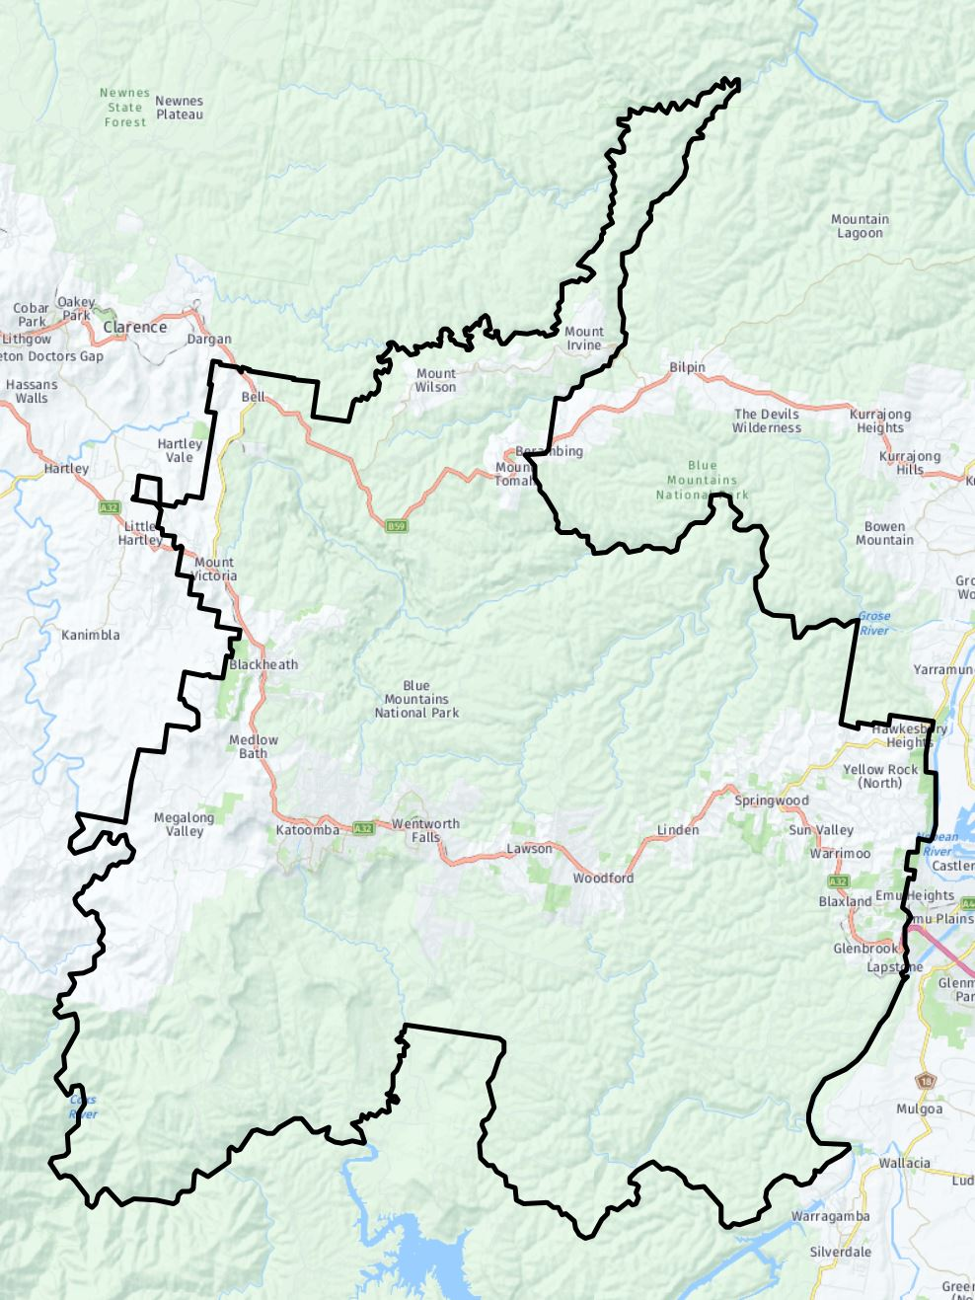
Township locations

Age Structure Blue Mountains Population
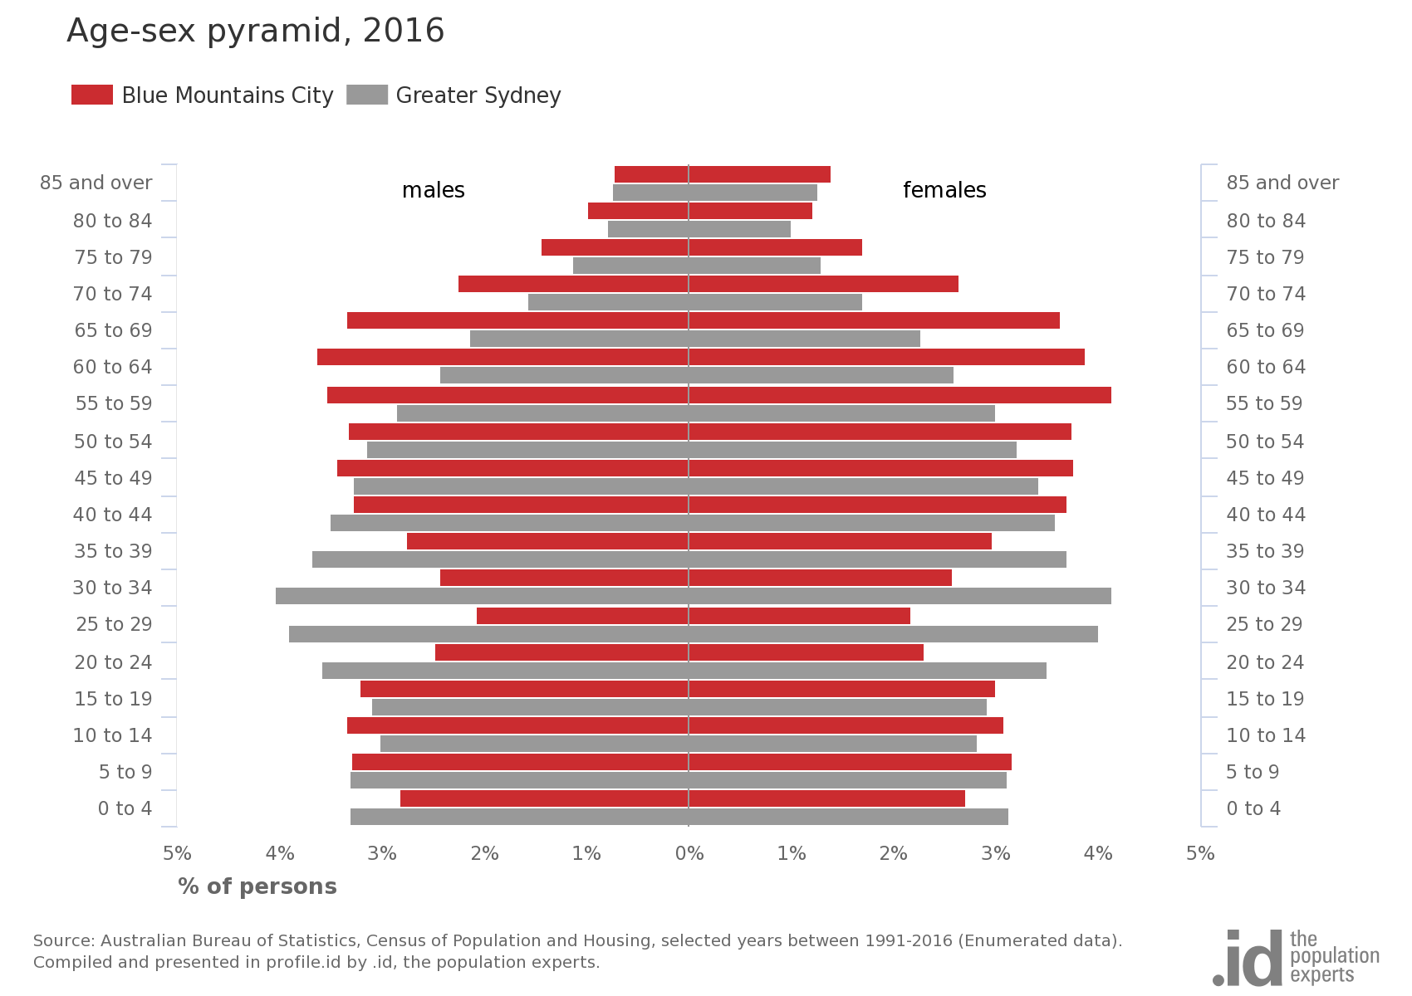
The age profile in 2016 for the Blue Mountains, and its comparison with Greater Sydney. (define ''Greater Sydney), is shown in the above chart (Census 2016). Key features of this profile are:
- the proportions of children and young people in the age range of 5 – 19 years old are similar to those of Greater Sydney.
- the proportions of children in the youngest age range of 0-4 years, are significantly lower than the Greater Sydney average. This suggest that either young families are not settling in the area, or the natural population increase is lower in the Blue Mountains is lower than the Greater Sydney average, or both.
- the proportions of people older than 45, but particularly above 55 years old, are much greater in the Blue Mountains than in the Greater Sydney. This "ageing" of the population has emerged in recent years across the state and nation across recent censuses, but is more marked in the Blue Mountains than in Greater Sydney and the State.
- Correspondingly, the proportion of people in "child- bearing" age of 20 - 44, particularly between 25 and 35, is much less than in Greater Sydney
- taking points 1. and 4. suggests that fewer adults are supporting more children and young people in the Blue Mountains than in Greater Sydney, on average
- taking points 1. and 3. together, suggests that older parents and grandparents may take a larger role in raising children and young people between the ages of 5 and 19 than they do in Greater Sydney.
Population Distribution and Density in the Blue Mountains
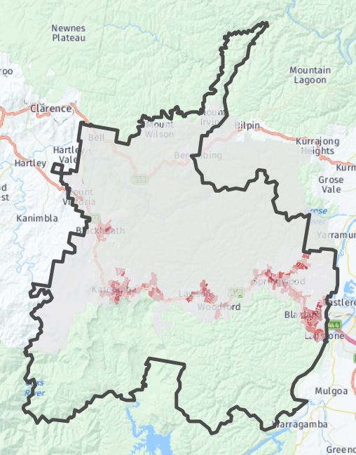
Population Distribution and Density
- Population is distributed across the LGA, in all areas except the National Parks
- Pattern of townships along the Transport Corridor – highway and rail line, also the Bell’s line of road in the North of the LGA 28 townships in all
- darker tone indicate higher density clustered

Wellbeing and Resilience in the Blue Mountains
(-findings available by April to be included when the Strategy is completed)
Numbers and Distribution of Children and Young People
Numbers and Percentages of Age Groupings : 0 - 24 Years
(2016 Census)
0 - 5 years​ |  | 6 - 12 years |  | 13 - 18 years |  | 19 - 24 years |  | Total
Nos. | % Total | Nos. | % Total | Nos. | % Total | Nos. | % Total
5,169 | 23% | 6,974 | 31% | 5,785 | 26% | 4,515 | 20% | 22,443
These figures s, the current slightly larger numbers of children will likely be reversed by the 2021 Census.
Distribution of Children and YP
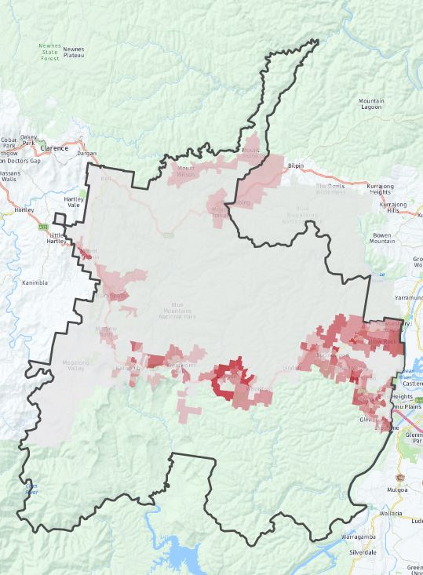 | 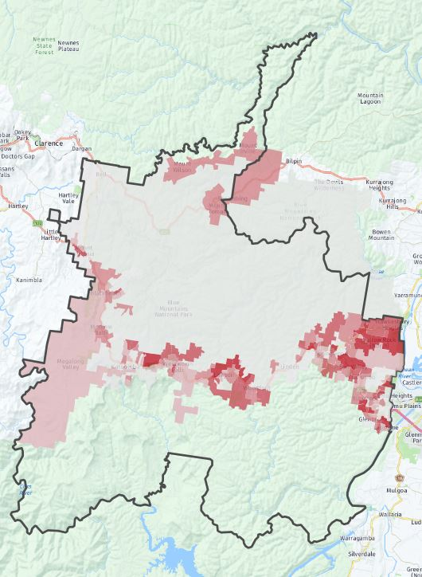
0 - 4 Year-old Children (numbers)  - clustered around the major townships in the Lower and Mid mountains, particularly Hazelbrook, Lawson, Winmalee, Yellowrock and Hawkesbury Heights  - Some in Upper mountains, particularly North Katoomba and North Leura | 5 - 11 Year- old Children (numbers)  - clustered around the major townships in the Lower and Mid mountains, particularly Hazelbrook, Lawson, Winmalee, Yellowrock, Hawkesbury Heights and Glenbrook  - Some in Upper mountains, particularly North Katoomba and North Leura, but generally more spread, including MT Wilson and Mt Tomah
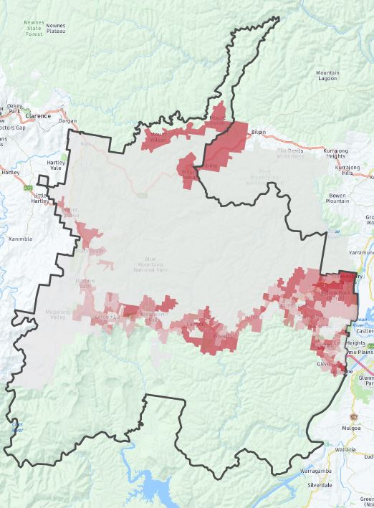 | 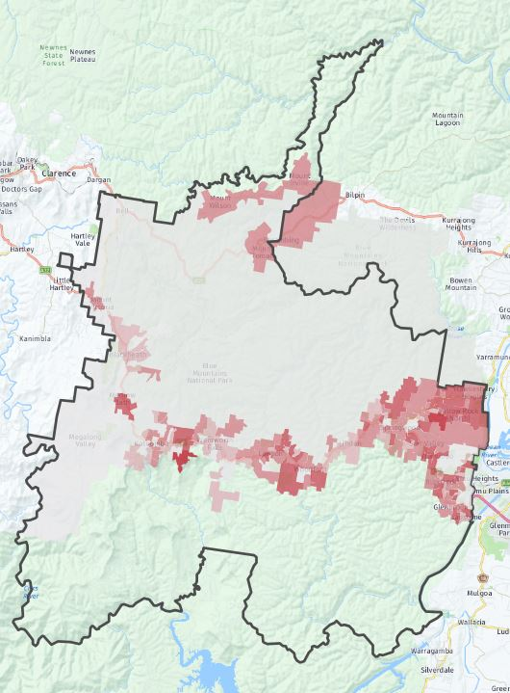
12 - 17 Year-old Young People (numbers)  - generally corresponding to the overall population distribution  - some concentration in parts of Lower mountains (Yellowrock, Hawkesbury Heights, MT Wilson and MT Tomah | 18– 24 Year-old Young People (numbers)  - generally corresponding to the overall population distribution  - some concentration in parts of Lower mountains (Yellowrock, Hawkesbury Heights, Medlow Bath and Leura

These maps illustrate the challenges in developing projects and participation across a fragmented and linear landscape. A focus on the Mid and Lower Mountains to all age groups is clearly warranted, but activity under this plan in the Upper Mountains and even the isolated areas of Mt Wilson and Mt Tomah would also be particularly valuable for young people.

Population Disadvantage
The maps below provide a broad (coarse- grained) comparison of relative "disadvantage" as described by the SEIFA index, derived from a number of demographic indices derived from the Census data set.
SEIFA Index of Disadvantage: (Census 2016)
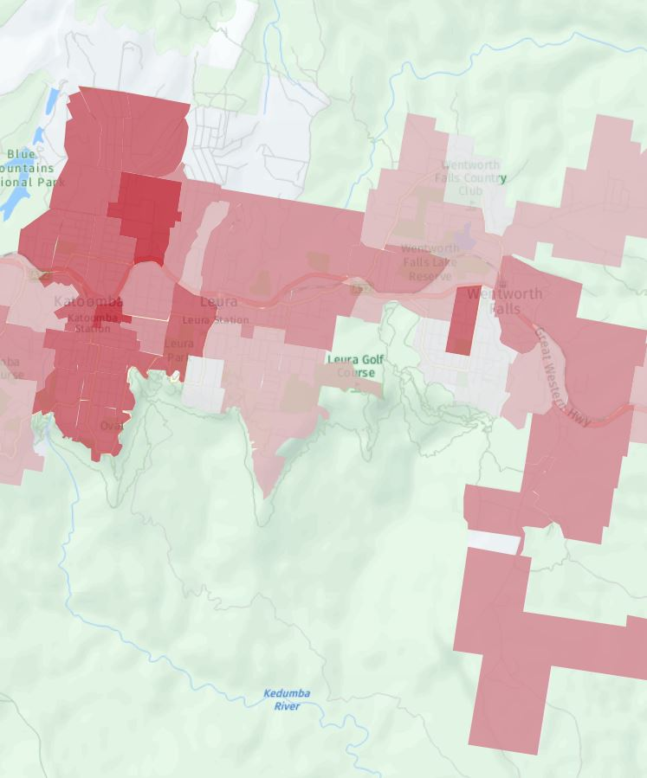 | 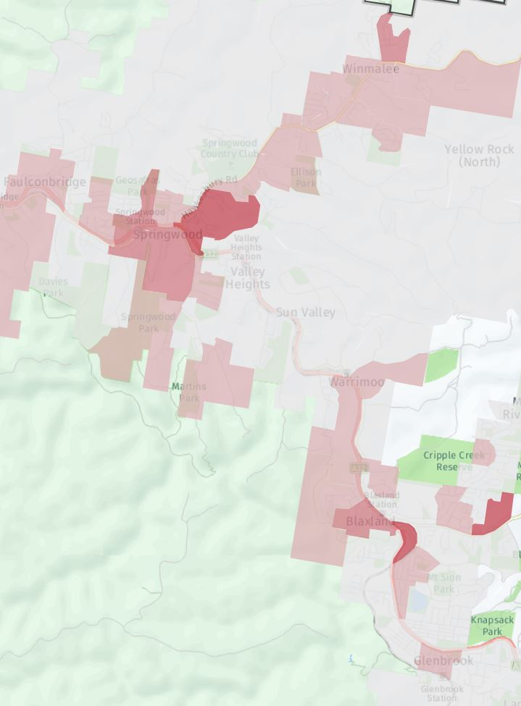
Katoomba to Wentworth Falls | Faulconbridge to Glenbrook
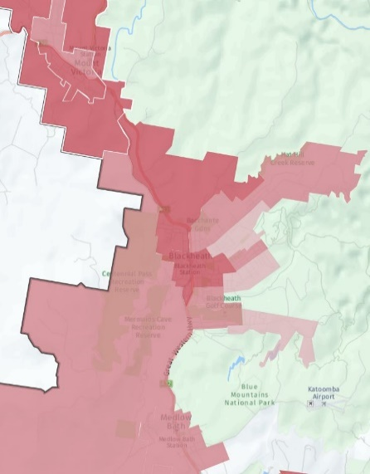 | 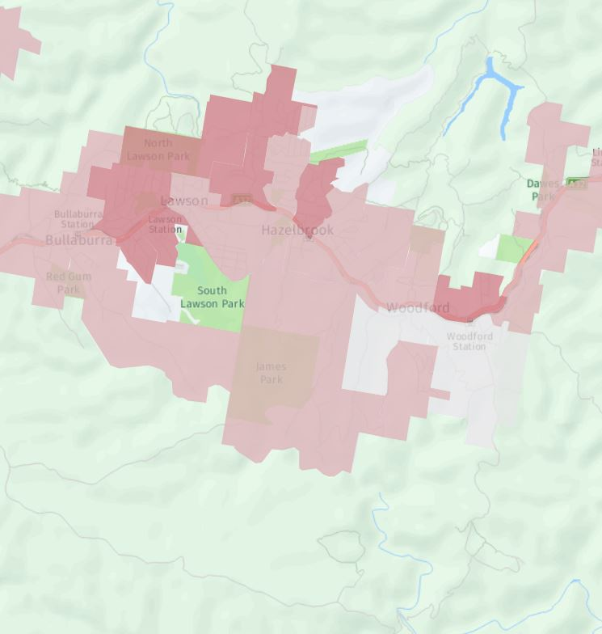
Medlowbath to Mt Victoria | Bullaburra to Linden
- Generally the Upper Mountains exhibits higher levels of disadvantage amongst the population than the Mid- or Lower Mountains
- Katoomba, particularly North Katoomba and parts of East Katoomba exhibit the highest levels of disadvantage, according to the SEIFA Index.
- Blackheath and Mt Victoria also exhibit higher levels of disadvantage and there are also "pockets" of disadvantage in the mid and lower Mountains
The SEIFA Index of disadvantage is particularly relevant to this Strategic Plan because it has been developed specifically to measure ''relative socio-economic advantage and disadvantage in terms of people's access to material and social resources, and their ability to participate in society.'' (SEIFA Technical Paper, 2033.0.55.001 – 2016). This focus on access and participation corresponds to the broad Outcomes and the Community Development priorities outlined above.
However, while these maps provide a convenient and visual comparison and ranking of different areas, there are important limitations to their interpretation. These limitations include that the Index "does not ...capture housing affordability, housing stress, dwelling value and dwelling quality'' (p.12.) and that "the need for a car varies depending on the remoteness of the area and access to public transport (p. 13). The issues of declining housing affordability / housing stress and isolation are identified by community agencies and Council as increasing concerns in 2019. Housing Affordability has been declining for both mortgages and rental due to the housing market boom and isolation is accentuated by the linear development pattern (along the highway railway corridor) of the areas, limited public transport and where people lack access to a private vehicle.
Household Income - Comparisons of Low Income and High Income households.
Low and High Income Households (Census 2016)
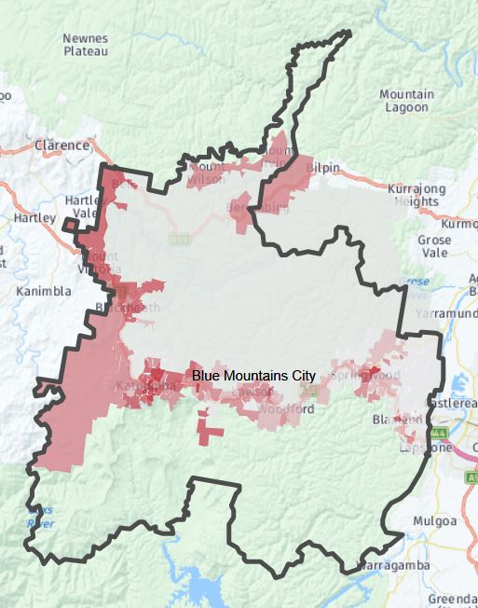 | 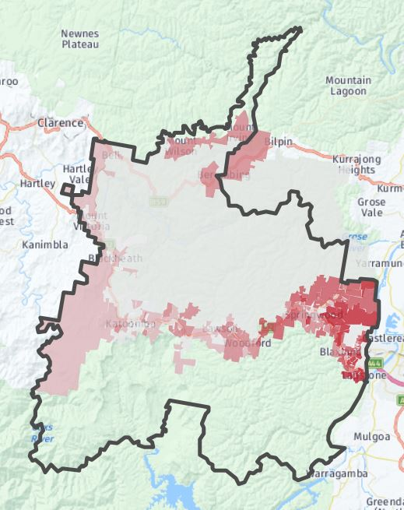
Low Income Households: (numbers) | High Income Households (numbers)
Household Income is a parameter in the SEIFA Index, but Income is of course a key factor in levels of individual and household disadvantage.
These maps demonstrate stark divide in income distribution between the Upper Mountains and Lower Mountains.
The high income distribution also mirrors the distribution of households where the mother is employed out of the home, which is another parameter collected by the Census.

Children’s Vulnerability
The below Table enumerates the variation in children's ''vulnerability" according to a measure of "two or more domains" (Definition…?)
Region  (including local  communities) | Children Vulnerable on two or more domains(s) (%)
 | 2009 | 2012 | 2015
Australia | 11.8 | 10.8 | 11.1
NSW | 10.3 | 9.2 | 9.6
Blue Mountains | 5.3 | 4.3 | 7.5
Upper Blue Mountains (Mt Victoria-Wentworth Falls)
Mount Victoria | - | - | -
Blackheath/Medlow Bath | 10.2 | 3.6 | 7.1
Katoomba | 5.2 | 3.6 | 7.6
Leura | 4.5 | 5.2 | 6.8
Wentworth Falls | 1.5 | 6.6 | 9.7
Mid Blue Mountains (Bullaburra-Faulconbridge)
Lawson/Bullaburra | 4.7 | 6.0 | 6.1
Hazelbrook | 6.3 | 8.3 | 5.5
Woodford/Linden | 4.3 | 6.7 | 3.6
Faulconbridge | 8.2 | 2.2 | 9.1
Lower Blue Mountains (Springwood-Lapstone)
Springwood | 6.5 | 4.6 | 7.1
Winmalee/Yellow Rock/Hawkesbury Heights | 7.6 | 1.8 | 6.3
Valley Heights | 0.0 | - | 9.1
Warrimoo | 0.0 | 3.0 | 7.7
Blaxland | 6.8 | 1.5 | 9.3
Mount Riverview | 3.0 | 2.2 | 16.2
Glenbrook/Lapstone | 2.9 | 3.7 | 4.9
To come: commentary on limitations and applicability

Data analysis - need detailed commentary on
- increasing vulnerability, despite lower overall, while these domains are declining in NSW as a whole.
- variability across the LGA.

- Proportions ranged from a low of 3.6% in Leura to a high of 7.2% in Hazelbrook.
  - Springwood - Valley Heights
  - Katoomba – Medlow Bath
  - Winmalee – Yellow Rock
  - Blaxland

- The five suburbs with the highest percentages were:
  - Hazelbrook (7.2%)
  - Warrimoo (7.0%)
  - Blaxland (6.5%)
  - Faulconbridge (6.4%)

An Indigenous Land Use Agreement (ILUA) is a voluntary agreement between a Native Title group and other parties on the use and management of land and waters. Indigenous Land Use a Agreements are established by the Native Title Act 1993. Native Title is the recognition in Australian law that some Indigenous people continue to hold communal, group or individual rights and interests to their lands and waters. These collective rights and interests come from traditional laws and customs. Native Title rights established by an ILUA have the same weight under federal law as a Native Title determination.
The Gundungurra people are represented in this agreement by the Gundungurra Tribal Council Aboriginal Corporation and the Gundungurra Aboriginal Heritage Association.
see Appendix 1 for detailed discussion on collaboration and the application of the Collective Impact Model
source to be cited here
source to be cited here
Collective Impact: evidence and implications for practice. CFCA Paper 45. A.I.F.S Aus. Govt. 2015
see Appendix 3 for detailed demographic and selected socio-economic data
Shared Measurement Framework for the Stronger Families Alliance: 2018: Regina Hill Consultants. Commissioned by BMCC.
Shared Measurement Framework for the Stronger Families Alliance: 2018: Regina Hill Consultants. Commissioned by BMCC.
Go to the Harwood Institute: https://theharwoodinstitute.org
See ''Harwood Community Consultation: Analysis report for the Blue Mountains City Council and the Stronger Families Alliance for children and young people: Ross Beaton Consulting: 2015
The three values inscribed in this definition are also reflected in Councils Community Strategic Plan, particularly in the section 3.1.C cited below (see: Relationship with Other Council Plans)
See “Collective Impact: evidence and implications for practice: 2017 CFCA Paper 45 ISBN: 978-1-76016-152-1”
See "The Solid Facts: Social Determinants of Health" 2003. World Health Organization : http://www.euro.who.int/__data/assets/pdf_file/0005/98438/e81384.pdf
See Intergenerational disadvantage14 Sep 2000 and Dropping off the edge 2015 Persistent communal disadvantage in Australia 21 Jul 2015; Tony Vinson, Margot Rawsthorne, Adrian Beavis, Mathew Ericson: Jesuit Social services: Catholic Social Services Australia. Accessed https://apo.org.au/node/18909 .
Kania, J and Kramer, M, “Collective Impact” in Stanford Social Innovation Review, Winter 2011, https://ssir.org
Coffman, J and Beer, T (2011) Evaluation to Support Strategic Learning: Principles and Practices, Centre for Evaluation Innovation, p1, https://evaluationinnovation.org
Hanleybrown, F, Kania, J and Kramer, M, “Channeling Change: Making Collective Impact Work” in Stanford Social Innovation Review, Jan 26, 2012, https://ssir.org
Cabaj, M and Weaver, L “Collective Impact 3.0: an Evolving Framework for Community Change” in https://collectiveimpactforum.org
Krania, J, Kramer, M, Senge, P “The Water of Systems Change” (May 2018) in https://fsg.org
Smart, J,“ Collective Impact: Evidence and Implications for Practice”, CFCA Paper No.45 – November 2017, https://aifs.gov.au
Woolf, T, “Ten Places Where Collective Impact Gets it Wrong” in Global Journal of Community Psychology Practice, v7, Issue 1March 15, 2016, https://gjcpp.org
Stachowiak, S and Gase, L “Does Collective Impact Really Make and Impact?” in Stanford Social Innovation Review, August 9, 2018, https://ssir.org
Moore, R, McDonald, Myfanwy, Hugh-Dillon, H, West, S “Community Engagement: A Key Strategy for Improving Outcomes for Australian Families” , CFCA Paper No.39 – April 2016, https://aifs.gov.au
https://iap2.org.au
Moore, R, McDonald, Myfanwy, Hugh-Dillon, H, West, S “Community Engagement: A Key Strategy for Improving Outcomes for Australian Families” , CFCA Paper No.39 – April 2016, https://aifs.gov.au
Smart, J, Smart, J,“ Collective Impact: Evidence and Implications for Practice”, CFCA Paper No.45 – November 2017, https://aifs.gov.au
Greater Sydney (Greater Capital City Statistical Area), as classified by the Australian Bureau of Statistics, covers 12,367.7 sq km and is made up of 35 local councils, extending from Wyong and Gosford in the north to the Royal National Park in the south, and includes the Blue Mountains, Wollondilly and Hawkesbury LGAs.
An additional limited AEDC collection took place in 2010 to include children from underrepresented communities. These results are reported in the 2009 results at a community level, though not included in the national and state/territory total.

