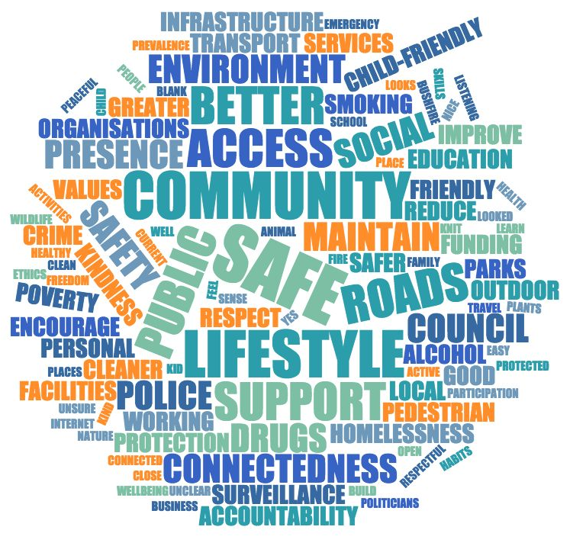

Blue Mountains Safe Communities Consultation Report: Community Aspirations, Values, Concerns and Actions

May 2019

Prepared for the Blue Mountains Lithgow Integrated Neighbourhood Centre Network by Maia Giordano for the Stronger Families Alliance and funded by the Blue Mountains City Council

Acknowledgement
We would like to acknowledge the coordinated efforts of the Stronger Families Alliance Child and Youth Friendly Cities Implementation Group convened by Belong Blue Mountains working with Blue Mountains Lithgow Integrated Neighbourhood Centre Networks (BLINN) and Mountains Youth Services Team.

We would like to acknowledge the work of staff and volunteers from Blackheath Area Neighbourhood Centre, Belong Blue Mountains – Katoomba Neighbourhood Centre, Belong Blue Mountains – Mid Mountains Neighbourhood Centre, Springwood Neighbourhood Centre Cooperative, Winmalee Neighbourhood Centre, Belong Blue Mountains – Lower Mountains Neighbourhood Centre, Mountains Outreach Community Services and the Mountains Youth Services Team.

In particular we extend our thanks to the Blue Mountains community; the residents that generously shared their views and the organisations that provided support and space for consultations. Thank you to:

- Blackheath Growers Market  - Ellison Public School  - Faulconbridge Public School  - Fun Day  - Glenbrook Growers Market  - Hazelbrook Public School  - Katoomba High School  - Katoomba Neighbourhood Centre  - Katoomba North Public School | - Katoomba Public School  - Katoomba Out of School Hours Care  - MYST Drop in Space  - Springwood Growers Market  - Springwood High School  - St Canices Primary Katoomba  - Winmalee High School  - Youth Council

We thank the Blue Mountains City Council and Bendigo Bank for their funding and support to enable this report to happen.
We look forward to working with the community, the Stronger Families Alliance and other key stakeholders to share the community knowledge in this report.

Cover page: Word frequency across all themes
Table of contents

Acknowledgement 3
Introduction 9
Outcomes Summary 9
Context 12
Child-Friendly Cities 12
What is a child-friendly city? 12
Methodology 13
The Harwood Public Innovation approach 13
Consultation process 13
Where we consulted 15
Coding and analysis 15
Process Review 16
Demographic overview 17
Age 17
Gender 18
Location 19
Results 20
Thematic snapshot 20
Theme summary overall 21
Location summary 6
Theme summary by gender 1
Aspirations for a safe community 5
Nice, friendly and kind 7
Close-knit, connected community 8
Safe from crime 8
Looking clean and well looked after 9
Kid and youth friendly 10
Safe roads 11
Safe people and places 11
Easy, safe access and travel 12
Respectful and open: people are free to be themselves 13
Aspirations for community by age and location 14
Aspirations by age 14
Aspirations by location 14
Values: Why is that important to you? 15
A sense of safety & freedom 17
Social & community connectedness 17
Safe roads and safe access 18
Maintaining a safe environment and current lifestyle 19
Wellbeing 19
Child Safe 20
Age comparison of values 21
Community concerns 22
Safety in public 24
Good as it is 25
Cleaner environment 26
Safer roads 26
Respect and kindness 28
Social connectedness and support 28
Child-Friendly 29
Age comparison of concerns 30
Actions to create change 31
Social connectedness and support 32
Better public facilities and infrastructure 33
Greater surveillance and police presence 34
Access, accountability and funding 35
Cleaner environment 35
Good and comfortable as it is 36
Improve parks and encourage outdoor lifestyle 37
Respect and kindness 37
Reduce smoking, alcohol and drugs 38
Safer roads 38
Child-friendly 39
Safe and increased public transport 40
Support local organisations and business 40
Specific concerns and actions that can help 40
Views of young people with disabilities 42
What makes you feel safe? 42
Friends and family 42
Safe people, places and activities 42
Being left alone 42
Values: What is it about those things that make you feel safe? 42
Actions to create change: What are some of the things that you think should change? 43
Being judged 43
Reduce drugs and crime 43
Employment, pay and conditions 43
People with disability having a say 43
Disability should be seen as a strength 43
Lack of trust in politicians 44
Disability businesses and supports 44
Public transport 44
Support for different groups 44
Look and feel of places 44
Where to next? 45
Where could this knowledge be used? 45
Who should this report be sent to? 45
Advocates and decision makers 45
Local groups and organisations who support community 45
Local Council 46
Law enforcement, roads, transport and emergency services 46
How should this report be embedded? 46
Engage children and young people in promoting this report 46
Use as a local evidence base for current and future work 47
Develop a local “own your part” campaign 47
Promoting action and ongoing conversation 47

Introduction
In 2015, Harwood Ask consultation were conducted in the Blue Mountains and Safety emerged as the top issue amongst the community.
Subsequently, the Blue Mountains Lithgow Integrated Neighbourhood Centres Network (BLINN) made an existing commitment to a Harwood Community Consultation focused on safety that was realised through the Stronger Families Alliance Child and Youth Friendly Cities Implementation Group.
The consultation opened a conversation with people in the community on their definition of a safe community as well as the values, concerns and actions that can make change to make their current community life safer. Conceptions of safety are highly subjective and can involve many different elements that contribute to a feeling and experience of safety in the community. This report is a first step for the Stronger Families Alliance identified priority on making the Blue Mountains a more Child-Friendly Community. It aims to better understand the views of the community, including children and young people, on what a safe community means to them and some practical areas in which greater community safety can be achieved.

Outcomes Summary
Across the Blue Mountains from Glenbrook to Lithgow, 541 community members of all ages shared their aspirations, values, concerns and actions to build a safer community in the Blue Mountains. 66% of the responses were from young people under 19 years of age and among these were 8 young people with disabilities (15 – 23 years). Child safe or child-friendly is a recurrent theme in this report, which highlights broad community support for building a more child-safe and child-friendly community across the Blue Mountains.
Recurrent Themes
What emerges are some recurrent themes in relation to the importance of:
- People treating each other well
- Social and community connection
- Safe roads
- Walking and moving around safely
- Infrastructure that supports safety, e.g. footpaths, lighting and crossings.
- Police presence and being safe from crime
- An environment that is clean and well looked after
- Child and youth friendly and safe
Age Related Differences in Response
There were some significant differences in responses made by those under 25 and those over 25, in particularly
- throughout this report it is young people emphasised the need for personal responsibility and behaviour in being “nice, friendly” or “kind” while adults more often highlighted the need for a more “child and youth friendly” community with places to play, opportunities to walk and ride safely, hang out and have things to do
- the majority (66%) of respondents under 25 did NOT perceive the community as safe, while only 44% of those over 25 felt this way.
Word Trees
A statistical analysis of terms used by respondents to the surveys indicated a number of words used repeatedly in a range of contexts. A visual representation of some key words identified in the review of the results, these being “kind”, “bullying”, “lights”, “fear” and “care”, are shown below. In this context, it is notable that
- approximately 90% of the usage of the terms “kind” and “bullying” were from under 25 year olds. This corroborates the point made in 1 above, and highlights the concern at bullying in this age group
- The very high reference to “lights” indicates the high importance of this infrastructure issue in perceptions of safety of public spaces.

Word Trees – Some significant terms that emerged from the Survey Responses
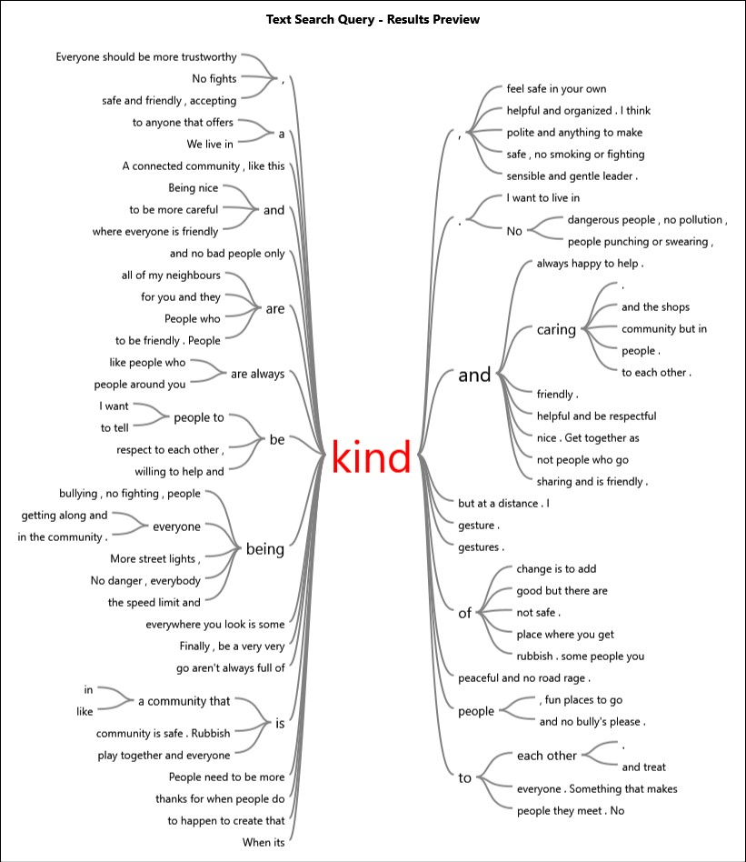 | 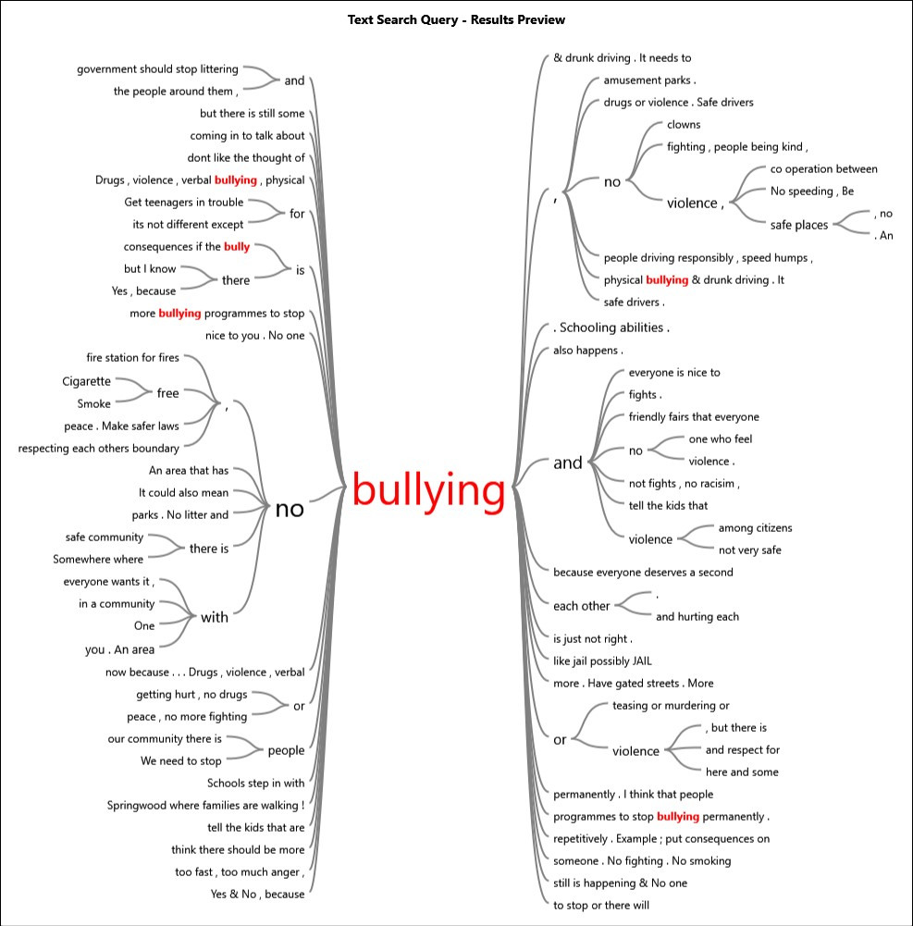
Word Trees – Some significant terms that emerged from the Survey Responses
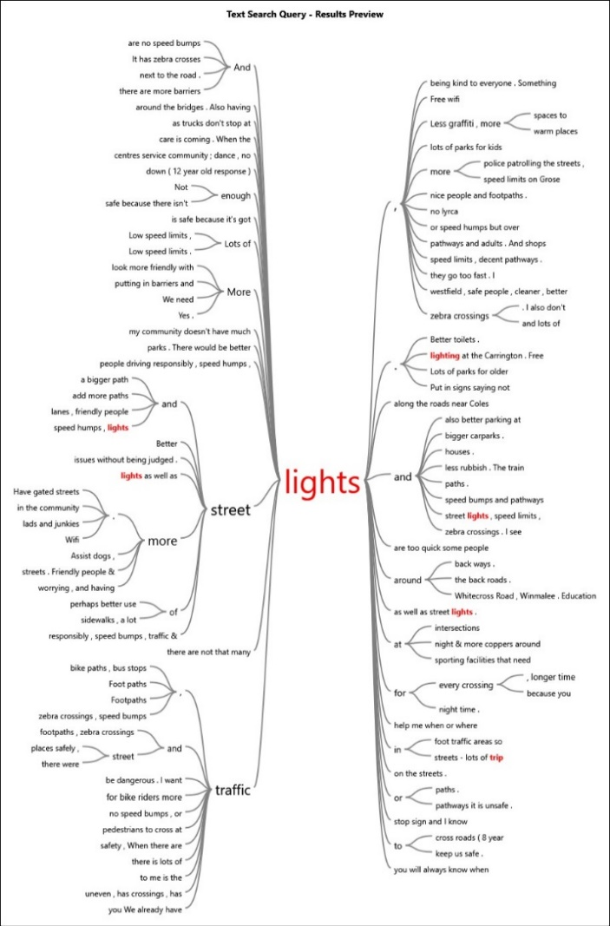 | 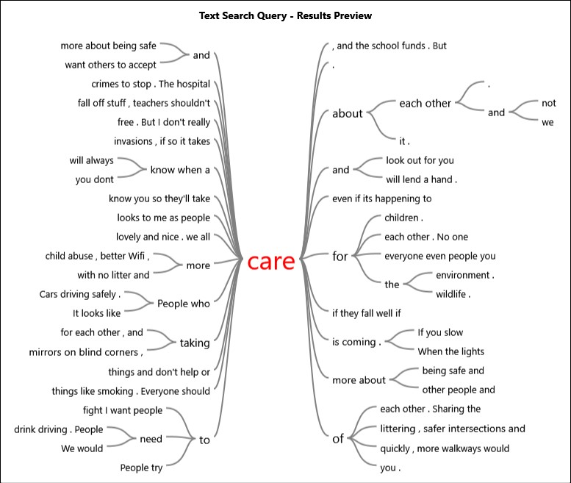  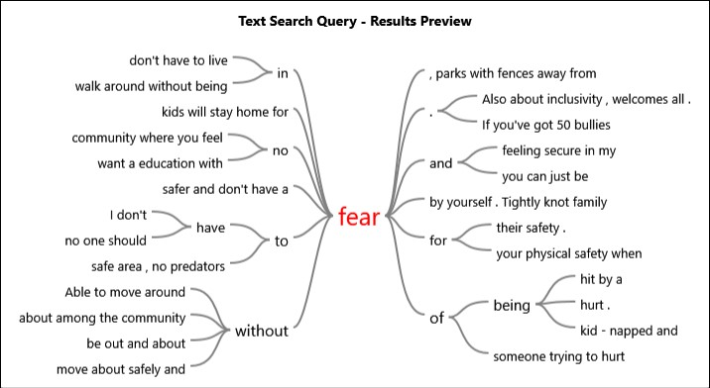

Context

Child-Friendly Cities

What is a child-friendly city?
A child-friendly city or community is one where the rights of Children (0-18 years) are upheld; rights as set out in the United Nations Convention on the Rights of the Child. These rights include four child rights principles:
- Non-discrimination (Article 2): Where all children, particularly those experiencing disadvantage and marginalisation, should be treated equally with others in the community and among all children and young people in a community.
- Best interests of the child (Article 3.1): Where the main focus in any decision concerning children, ensures the ‘best interests of the child’ are front and centre.
- The inherent right to life, survival and development (Article 6): Where children as much as possible should be able to survive, develop and thrive.
- Respect for the views of the child (Article 12): Where children’s right to have a say is upheld and their views are considered in decisions that affect them.
The UNICEF Child-Friendly Cities Initiative (CFCI) fosters communities "where the voices, needs, priorities and rights of children are an integral part of public policies, programmes and decisions." Indeed research has shown that a city that is ‘child-friendly’ by implication becomes a city that is safer and more accessible for all generations, backgrounds and abilities. Ultimately, a city that is ‘child-friendly’ benefits everyone, it is more safe, accessible, liveable, and welcoming of all people, especially its youngest citizens.
All people, but particularly parents, have an important role to play in creating a child-friendly city. Indeed parental fears for children’s safety limits their independence and freedom. Therefore a safer, child-friendly community will enable greater autonomy and growth for a community’s youngest citizens.
The very approach of the CFCI denotes a commitment to the local context of a city or community and how that local lens can facilitate children's rights. Children's right to have a say and participate in decisions that affect them and their community (as set out in Article 12) is at the heart of building a more Child-Friendly Community.

Methodology

The Harwood Public Innovation approach
The Harwood Public Innovation approach is committed to capturing community knowledge that reflects the true voice of the community and thus every effort was made to record responses verbatim without paraphrasing or summarising. So too the coding of themes, analysis and subsequent report all endeavour to stay true to and showcase the voice and phrasing of community responses to the Harwood ASK questions, set out below.
The Harwood Public Innovation approach aims to capture and reflect the aspirations, values, concerns and actions of the community in which consultations were held rather than necessarily align with the rigours of academic social research. That being said, the methodology for capturing and reporting on the results has used social research methodology in the coding and analysis of this report.
The Harwood approach also involves a cross-check process with workers who were part of the consultations to ensure the way emergent themes were described aligned with their reflections on themes and phrases that were highlighted during the consultations. Changes made during this process did not alter the results but ensured the way the overarching themes were reported better aligned with the way the community described their overarching aspirations and concerns.

Consultation process
BLINN - comprising of neighbourhood centres in the Blue Mountains and Lithgow areas - and Mountains Youth Services Team (MYST) have worked together using the Harwood Public Innovation approach to better understand the community knowledge and aspirations for a safe community in the Blue Mountains. Overall, 16 consultations were conducted in 2018, using the Harwood ASK consultation tool that sets out four questions, namely:
- What does a safe community look like to you?
- Why is that important?
- Is your idea of a safe community different from how you see things now? How is that different from how you see things now?
- What are some of the things that need to happen to create that kind of change?
The consultation tool was administered through either workers or volunteers writing down the responses or – in the case of some of the school consultations – community members writing their own responses.

Where we consulted
Face-to-face Harwood ASK consultations were conducted from Lower to Upper Blue Mountains at the following places/events:
- Blackheath Growers Market  - Ellison Public School  - Faulconbridge Public School  - Fun Day  - Glenbrook Growers Market  - Hazelbrook Public School  - Katoomba High School  - Katoomba Neighbourhood Centre  - Katoomba North Public School | - Katoomba Public School  - Katoomba Out of School Hours Care  - MYST Drop in Space  - Springwood Growers Market  - Springwood High School  - St Canices Primary Katoomba  - Winmalee High School  - Youth Council

In addition to the face-to-face consultations, an online survey with the four modified Harwood ASK questions was available to the community for over a month.
Children and young people were consulted predominantly in a school setting and a cross-section of the community was consulted at some of the Growers Markets and Fun Days from Glenbrook to Blackheath. There was one group conversation conducted at a Youth Centre in the upper Blue Mountains with a group of young people with disabilities.

Coding and analysis
Data coding was conducted to determine categories and sub-categories for each question. Categories were developed through reviewing responses and ensuring each element of individual answers were attributed a relevant code. In some cases up to 5 categories were attributed to a single response to ensure that all the issues raised by the community were captured in the analysis. Once sub-categories were developed they were then grouped into overarching categories and reviewed to ensure the wording of the themes met two criterion, namely that they reflected the words and intention of community voice and they were phrased in response to the relevant question. For example, in question one many responses related to ‘how people treat each other’ in the community so the category “Nice, friendly and kind” was named to reflect the main types of words used by the community in relation interpersonal relationships as well as crafted to respond to the initial question.
For the first question “What does a safe community look like to you?”, Blue Mountains City Council generously assisted with categorising data for one of the questions using the NVivo software – a qualitative data analysis software. This process was used to generate the overarching themes for the community responses overall as well as for age, gender (26 years and over) and regional location.
In relation to the remaining three questions (Questions 2 to 4), a manual coding process for sub-categories and finally overarching themes were adopted using excel and word frequency tools to generate overarching themes. The sub-categories assisted with analysing the major themes within each category. Themes were ranked and analysed based on theme frequency. In keeping with the Harwood Public Innovation approach, the report is structured to ensure that the phrasing and direct quotes from community members form the bulk of the report, bracketed by summary and analysis to highlight the themes raised by the community.

Process Review
In keeping with the Harwood Public Innovation approach, the themes emerging from key questions were discussed with Community Development Workers from four different Neighbourhood Centres in the Blue Mountains as well as capturing reflections and learning’s from the consultations. This cross-checking process is in keeping with the Harwood Public Innovation approach as another layer of checking that themes emerging reflected the way in which the community described these issues. This process does not serve to change or alter the themes but is a chance for those who work closely with the communities to provide feedback on their reflections of themes emerging and ensure the way themes are described reflect the voice of the community.
Workers highlighted that some themes that were major issues in individual consultations reflected a ‘moment in time’ context in which the consultations were conducted. They do not necessarily reflect the ongoing or major concerns of the community. For example one consultation occurred the day after an article in the local newspaper about the need for a local Hospital in the Mid Mountains area, subsequently many children at this consultation raised the need for a local hospital as a major safety concern.
In the demographic section, gender was not always asked for a variety of reasons that were decided by individual workers in consultations. Thus in 42 percent of responses the gender question was either not asked or intentionally left blank by respondents. As a result gender analysis of responses by those under 25 years of age was not possible.
In reflecting on Question 3 “Is your idea of a safe community different from how you see things now? How is that different from how you see things now?”, some workers found that children and young people had difficulty understanding what was being asked. The question was changed to a Yes or No question rather than open-ended to make sense to a younger audience. However one worker reflected that this change to Question 3 made it worse. This approach may not have been consistently applied.
Future consultations should endeavour to create a consistent approach prior to the data collection phase.
Future consultations should aim for consistency in how the survey tool is applied and the questions asked, including demographic questions such as gender and age. In relation to the latter, age brackets should be used that better reflect the stage of life for respondents 25 years and under, for example age ranges would be better aligned to pre-school, primary, high school and post-school.
In the coding and analysis process, the manual coding rather than NVivo software proved to be a better tool for analysing and developing overarching themes from the community consultations. In relation to the theme of Sense of safety and freedom for example, the sub-category of personal safety was described by the community in a multitude of ways that could not be adequately captured through inputting codes into the NVivo software. Manual coding allowed the overarching themes to capture ‘the pulse’ of the community responses on such complex issues as perceptions of and sense of safety.

Demographic overview

Age
Overall, children and young people, 15 years and under, were by far the largest age group at 62 per cent of all respondents. The remaining ages groups, 26 years and over make up 36.3 per cent of respondents and a minimal 1.9 per cent of respondents did not have their age recorded.
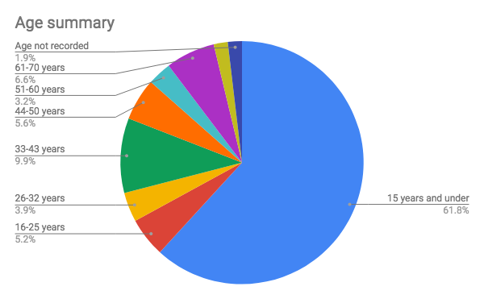
Figure 1 Age breakdown for the Blue Mountains: 2016 Census

Gender
Almost half (42%) of respondents did not answer or were not asked the gender question. Overall, 33 percent of respondents selected female, 24 percent male and finally one percent identified as Gender Diverse.
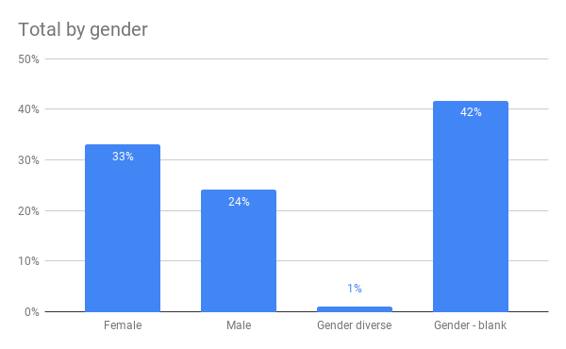
Figure 2 Gender summary

Location
Locations were divided into regions of Upper, Middle and Lower Mountains. Some suburbs had less than 5 responses so this approach allows for a reporting of feedback without identifying individual respondents.

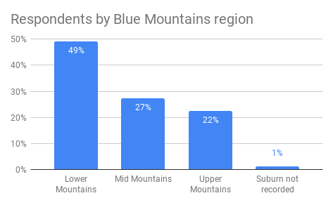

Figure 3 Location summary

Results

Thematic snapshot
This section provides a comparative data summary of all questions in relation to the overall community responses as well as specific summaries of thematic results by age, gender (for 26 years and over) as well as location.
For those groups where the number of responses were less than 100 people (n=<100) themes with a count (#) five or less incidence were amalgamated into the “Other” category. However for response groups where there were more than 100 people (n=>100), themes with a count (#) of 10 or less were amalgamated into the “Other” category.

Across all four key areas of this consultation there are some obvious common threads (outlined in Table 4 below) with themes relating to how people treat each other (e.g. nice, friendly and kind) or social connectedness appearing in the top ranked themes. So too perceptions or feelings of safety ranked highly with Sense of safety and freedom as well as Safety in public appearing as the top theme for Question 2 and 3 respectively.
The subsequent sections provide detail and context for each of the themes named in the summary thematic tables.

Theme summary overall
Aspirations - Question 1  What does a safe community look like to you? |  |  | Values - Question 2  Why is that important?
(n=533) |  |  | (n=533)
Theme | # | % | Theme | # | %
Nice, friendly and kind | 293 | 20% | Sense of safety and freedom | 388 | 36%
Close knit, connected community | 157 | 10% | Social and community connectedness | 177 | 16%
Safe people and places | 152 | 10% | To have safe roads and safe access | 157 | 15%
Safe from crime | 124 | 8% | Maintain safe environment and current lifestyle | 105 | 10%
A place that looks clean and well looked after | 119 | 8% | Wellbeing | 96 | 9%
Kid friendly | 111 | 7% | Child Safe | 69 | 6%
Safe roads | 110 | 7% | Protection by emergency services and prevalence of crime and drugs | 39 | 4%
Easy, safe access and travel | 103 | 7% | Family | 21 | 2%
People are free to be themselves | 80 | 5% | To build skills and learn | 10 | 1%
Activities that feel safe | 69 | 5% | Other | 11 | 1%
Health Services and healthy habits | 47 | 3%
Active participation | 45 | 3%
Police presence | 43 | 3%
Safe and protected nature, plants and wildlife | 20 | 1%
Fire safe | 13 | 1%
Other | 14 | 1%
Figure 4 Theme summary comparison for questions 1 to 2

Concerns - Question 3  Is your idea of a safe community different from how you see things now? How is that different from how you see things now? |  |  | Actions for change - Question 4  What are some of the things that need to happen to create that kind of change?
(n=533) |  |  | (n=496)
Theme | # | % | Theme | # | %
Safety in public | 159 | 24% | Better public facilities and infrastructure | 119 | 14%
Good as it is | 136 | 21% | Social connectedness and support | 117 | 14%
Cleaner environment | 54 | 8% | Greater surveillance and police presence | 102 | 12%
Respect and kindness | 47 | 7% | Access, accountability and funding | 65 | 8%
Safer roads | 47 | 7% | Cleaner environment | 59 | 7%
Social, connectedness and support | 42 | 6% | Improve parks and encourage outdoor lifestyle | 53 | 6%
Child-Friendly | 35 | 5% | Respect and kindness | 52 | 6%
Reduce smoking, alcohol and other drugs | 33 | 5% | Reduce smoking, alcohol and drugs | 46 | 6%
Better public facilities and infrastructure | 31 | 5% | Good and comfortable as it is | 46 | 6%
Improve parks and encourage outdoor lifestyle | 17 | 3% | Safer roads | 42 | 5%
Maintain community values and lifestyle | 13 | 2% | Child-friendly | 35 | 4%
Greater surveillance and police presence | 13 | 2% | Safe and increased public transport | 24 | 3%
Safe and better public transport | 11 | 2% | Support local organisations and business | 22 | 3%
Other | 14 | 2% | Bushfire, environment and animal protection | 17 | 2%
 |  |  | Community Education | 12 | 1%
 |  |  | Other | 23 | 3%
Figure 5 Theme summary comparison for questions 3 to 4

Age summary
Question 1: What does a safe community look like to you?
25 years and under (n=359) |  |  | 26 years and over (n=165)
Theme | # | % | Theme | # | %
Nice, friendly and kind | 226 | 21% | Close knit, connected community | 69 | 16%
Safe people and places | 109 | 10% | Nice, friendly and kind | 67 | 16%
A place that looks clean and well looked after | 102 | 10% | Safe people and places | 43 | 10%
Safe from crime | 98 | 9% | Easy, safe access and travel | 41 | 10%
Close knit, connected community | 88 | 8% | Kid friendly | 40 | 9%
Safe roads | 78 | 7% | Safe roads | 32 | 7%
Kid friendly | 71 | 7% | Safe from crime | 26 | 6%
Easy, safe access and travel | 62 | 6% | Respectful and open | 23 | 5%
Respectful and open | 57 | 5% | Activities that feel safe | 21 | 5%
Activities that feel safe | 48 | 4% | Active participation | 19 | 4%
Health Services and healthy habits | 42 | 4% | A place that looks clean and well looked after | 17 | 4%
Police presence | 31 | 3% | Police presence | 12 | 3%
Active participation | 26 | 2% | Other | 6 | 1%
Figure 6 Comparison by age for Question 1 themes

Question 2: Why is that important?
25 years and under (n=359) |  |  | 26 years and over (n=165)
Theme | # | % | Theme | # | %
Sense of safety and freedom | 284 | 39% | Sense of safety and freedom | 79 | 27%
To have safe roads and safe access | 135 | 19% | Social and community connectedness | 78 | 26%
Social and community connectedness | 89 | 12% | Child Safe | 37 | 12%
Wellbeing | 71 | 10% | Maintain safe environment and current lifestyle | 30 | 10%
Maintain safe environment and current lifestyle | 60 | 8% | To have safe roads and safe access | 29 | 10%
Prevalence of crime and drugs (and emergency services) | 31 | 4% | Wellbeing | 22 | 7%
Child Safe | 26 | 4% | Other | 22 | 7%
Family | 11 | 2%
To build skills and learn | 10 | 1%
Other | 7 | 1%
Figure 7 Comparison by age for Question 2 themes

Question 3: Is your idea of a safe community different from how you see things now? How is that different from how you see things now?
25 years and under (n=359) |  |  | 26 years and over (n=165)
Theme | # | % | Theme | # | %
Safety in public | 142 | 29% | Good as it is | 78 | 33%
Good as it is | 56 | 11% | Social, connectedness and support | 24 | 10%
Cleaner environment | 50 | 10% | Safety in public | 15 | 6%
Safer roads | 36 | 7% | Respect and kindness | 15 | 6%
Respect and kindness | 31 | 6% | Child-Friendly | 14 | 6%
Reduce smoking, alcohol and other drugs | 29 | 6% | Maintain community values and lifestyle | 12 | 5%
Better public facilities and infrastructure | 25 | 5% | Improve parks and encourage outdoor lifestyle | 11 | 5%
Child-Friendly | 20 | 4% | Safer roads | 10 | 4%
Social, connectedness and support | 18 | 4% | Other | 17 | 8%
Safe and better public transport | 9 | 2%
Other | 13 | 2%
Figure 8 Comparison by age for Question 3 themes

Question 4: What are some of the things that need to happen to create that kind of change?
25 years and under (n=345) |  |  | 26 and over (n=152)
Theme | # | % | Theme | # | %
Better public facilities and infrastructure | 83 | 16% | Social connectedness and support | 58 | 24%
Greater surveillance and police presence | 77 | 15% | Better public facilities and infrastructure | 34 | 14%
Social connectedness and support | 58 | 11% | Access, accountability and funding | 26 | 11%
Cleaner environment | 56 | 11% | Greater surveillance and police presence | 23 | 9%
Respectful and open | 50 | 10% | Good and comfortable as it is | 23 | 9%
Reduce smoking, alcohol and drugs | 42 | 8% | Improve parks and encourage outdoor lifestyle | 18 | 7%
Access, accountability and funding | 38 | 7% | Child-friendly | 17 | 7%
Improve parks and encourage outdoor lifestyle | 34 | 6% | Support local organisations and business | 15 | 6%
Safer roads | 30 | 6% | Safer roads | 11 | 4%
Good and comfortable as it is | 24 | 5% | Other | 20 | 8%
Child-friendly | 18 | 3%
Safe and increased public transport | 16 | 3%
Figure 9 Comparison by age for Question 4 themes

Location summary
Question 1: What does a safe community look like to you?
Lower Mountains (n=260) |  |  | Mid Mountains (n=147) |  |  | Upper Mountains (n=121)
Theme | # | % | Theme | # | % | Theme | # | %
Nice, friendly and kind | 154 | 20% | Nice, friendly and kind | 72 | 19% | Nice, friendly and kind | 67 | 19%
Safe people and places | 77 | 10% | A place that looks clean and well looked after | 49 | 13% | Close knit, connected community | 49 | 14%
Close knit, connected community | 75 | 10% | Road safety | 37 | 10% | Safe people and places | 41 | 12%
Safe from crime | 69 | 9% | Safe people and places | 34 | 9% | Easy, safe access and travel | 28 | 8%
Kid friendly | 64 | 8% | Safe from crime | 34 | 9% | Kid friendly | 28 | 8%
Road safety | 58 | 8% | Close knit, connected community | 33 | 9% | Equitable and open | 24 | 7%
A place that looks clean and well looked after | 52 | 7% | Easy, safe access and travel | 25 | 7% | Safe from crime | 21 | 6%
Easy, safe access and travel | 50 | 7% | Kid friendly | 19 | 5% | A place that looks clean and well looked after | 18 | 5%
Equitable and open | 39 | 5% | Activities that feel safe | 18 | 5% | Active participation | 16 | 5%
Activities that feel safe | 38 | 5% | Equitable and open | 17 | 4% | Road safety | 15 | 4%
Police Presence | 29 | 4% | Health Services and healthy habits | 13 | 3% | Activities that feel safe | 13 | 4%
Figure 10 Comparison by location for Question 1 themes

Question 2: Why is that important?
Lower Mountains (n=260) |  |  | Mid Mountains (n=147) |  |  | Upper Mountains (n=121)
Theme | # | % | Theme | # | % | Theme | # | %
Sense of safety and freedom | 196 | 37% | Sense of safety and freedom | 101 | 36% | Sense of safety and freedom | 99 | 39%
To have safe roads and safe access | 93 | 17% | Social and community connectedness | 40 | 14% | Social and community connectedness | 59 | 23%
Social and community connectedness | 74 | 14% | To have safe roads and safe access | 36 | 13% | To have safe roads and safe access | 28 | 11%
Maintain safe environment and current lifestyle | 49 | 9% | Maintain safe environment and current lifestyle | 33 | 12% | Wellbeing | 22 | 9%
Child Safe | 38 | 7% | Wellbeing | 29 | 10% | Child Safe | 16 | 6%
Wellbeing | 44 | 8% | Child Safe | 15 | 5% | Maintain safe environment and current lifestyle | 13 | 5%
Protection by emergency services and prevalence of crime and drugs | 24 | 4% | Protection by emergency services and prevalence of crime and drugs | 13 | 5% | Other | 17 | 7%
Other | 17 | 3% | Other | 10 | 4%
Figure 11 Comparison by location for Question 2 themes

Question 3: Is your idea of a safe community different from how you see things now? How is that different from how you see things now?
Lower Mountains (n=252) |  |  | Mid Mountains (n=145) |  |  | Upper Mountains (n=111)
Theme | # | % | Theme | # | % | Theme | # | %
Safety in public | 91 | 25% | Safety in public | 46 | 22% | Good as it is | 38 | 22%
Good as it is | 64 | 18% | Good as it is | 32 | 15% | Safety in public | 23 | 13%
Cleaner environment | 28 | 8% | Cleaner environment | 18 | 9% | Child-Friendly | 10 | 6%
Respect and kindness | 25 | 7% | Safer roads | 18 | 9% | Better public facilities and infrastructure | 10 | 6%
Social, connectedness and support | 22 | 6% | Respect and kindness | 14 | 7% | Other | 51 | 30%
Safer roads | 22 | 6% | Reduce smoking, alcohol and other drugs | 14 | 7%
Child-Friendly | 17 | 5% | Social, connectedness & support | 12 | 6%
Better public facilities and infrastructure | 13 | 4% | Child-Friendly | 8 | 4%
Reduce smoking, alcohol and other drugs | 12 | 3% | Better public facilities & infrastructure | 8 | 4%
Other | 69 | 19% | Other | 40 | 19%
Figure 12 Comparison by location for Question 3 themes

Question 4: What are some of the things that need to happen to create that kind of change?
Lower Mountains (n=246) |  |  | Mid Mountains (n=142) |  |  | Upper Mountains (n=109)
Theme | # | % | Theme | # | % | Theme | # | %
Social connectedness and support | 57 | 14% | Better public facilities and infrastructure | 41 | 19% | Social connectedness and support | 35 | 17%
Greater surveillance and police presence | 56 | 14% | Greater surveillance and police presence | 31 | 14% | Access, accountability and funding | 29 | 14%
Better public facilities and infrastructure | 56 | 14% | Social connectedness and support | 22 | 10% | Better public facilities and infrastructure | 22 | 11%
Respectful and open | 37 | 9% | Cleaner environment | 21 | 10% | Safe and increased public transport | 16 | 8%
Improve parks and encourage outdoor lifestyle | 30 | 7% | Reduce smoking, alcohol and drugs | 16 | 7% | Greater surveillance and police presence | 15 | 7%
Cleaner environment | 30 | 7% | Safer roads | 13 | 6% | Improve parks and encourage outdoor lifestyle | 12 | 6%
Access, accountability and funding | 26 | 6% | Good and comfortable as it is | 12 | 6% | Child-friendly | 10 | 5%
Good and comfortable as it is | 24 | 6% | Improve parks and encourage outdoor lifestyle | 11 | 5% | Good and comfortable as it is | 10 | 5%
Safer roads | 21 | 5% | Other | 50 | 23% | Reduce smoking, alcohol and drugs | 10 | 5%
Reduce smoking, alcohol and drugs | 20 | 5% |  |  |  | Other | 43 | 21%
Child-friendly | 16 | 4%
Other | 39 | 9%
Figure 13 Comparison by location for Question 4 themes

Theme summary by gender
Question 1: What does a safe community look like to you?
Female  26 years and over (n=105) |  |  | Male  26 years and over (n=51)
Close knit, connected community | 64 | 20% | Close knit, connected community | 23 | 24%
Nice, friendly & kind | 33 | 10% | Road safety | 11 | 11%
Easy, safe access and travel | 33 | 10% | Nice, friendly & kind | 10 | 10%
Kid friendly | 32 | 10% | Safe people and places | 10 | 10%
Safe people and places | 32 | 10% | Safe from crime | 8 | 8%
Equitable and open | 22 | 7% | Easy, safe access and travel | 7 | 7%
Road safety | 21 | 7% | A place that looks clean and well looked after | 6 | 6%
Activities that feel safe | 18 | 6% | Kid friendly | 6 | 6%
Safe from crime | 16 | 5% | Active participation | 5 | 5%
Active participation | 13 | 4% | Other | 11 | 11%
A place that looks clean and well looked after | 10 | 3%
Other | 21 | 7%
Figure 14 Comparison by gender for respondents over 26 years for Question 2 themes

Question 2: Why is that important?
Female  26 years and over (n=103) |  |  | Male  26 years and over (n=51)
Theme | # | % | Theme | # | %
Sense of safety and freedom | 64 | 29% | Social and community connectedness | 26 | 27%
Social and community connectedness | 60 | 27% | Sense of safety and freedom | 25 | 26%
Child Safe | 35 | 16% | Maintain safe environment and current lifestyle | 10 | 10%
Maintain safe environment and current lifestyle | 21 | 9% | To have safe roads and safe access | 9 | 9%
To have safe roads and safe access | 20 | 9% | Child safe | 8 | 8%
Wellbeing | 14 | 6% | Wellbeing | 8 | 8%
Other | 20 | 9% | Family | 5 | 5%
 |  |  | Other | 6 | 6%
Figure 15 Comparison by gender for respondents over 26 years for Question 2 themes

Question 3: Is your idea of a safe community different from how you see things now? How is that different from how you see things now?
Female  26 years and over (n=104) |  |  | Male  26 years and over (n=51)
Theme | # | % | Theme | # | %
Good and comfortable as it is | 45 | 30% | Good and comfortable as it is | 25 | 36%
Social connectedness and support | 16 | 11% | Social connectedness and support | 7 | 10%
Child-friendly | 12 | 8% | Safety in public | 5 | 7%
Respect and kindness | 10 | 7% | Safer roads | 5 | 7%
Improve parks and encourage outdoor lifestyle | 10 | 7% | Other | 27 | 39%
Safety in public | 9 | 6%
Maintain community values and lifestyle | 8 | 5%
Safer roads | 5 | 3%
Other | 35 | 23%
Figure 16 Comparison by gender for respondents over 26 years for Question 3 themes

Question 4: What are some of the things that need to happen to create that kind of change?
Female  26 years and over (n=178) |  |  | Male  26 years and over (n=72)
Theme | # | % | Theme | # | %
Social connectedness and support | 43 | 23% | Social connectedness and support | 13 | 17%
Better public facilities and infrastructure | 22 | 12% | Good and comfortable as it is | 10 | 13%
Access, accountability and funding | 19 | 10% | Better public facilities and infrastructure | 9 | 12%
Greater surveillance and police presence | 16 | 9% | Child-friendly | 7 | 9%
Improve parks and encourage outdoor lifestyle | 14 | 8% | Access, accountability and funding | 7 | 9%
Good and comfortable as it is | 13 | 7% | Greater surveillance and police presence | 7 | 9%
Support local organisations and business | 11 | 6% | Other | 19 | 25%
Child-friendly | 9 | 5%
Other | 31 | 17%

Figure 17 Comparison by gender for respondents over 26 years for Question 4 themes

Aspirations for a safe community
Overall, Blue Mountains community defines a safe community as a place that is:
- Nice, friendly and kind
- Close-knit, connected community
- Safe from crime
- Looking clean and well looked after
- Kid and youth friendly
- Road safe
- Safe people and places
- Easy, safe access and travel
- Respectful and open: people are free to be themselves

Figure 18 Question 1 theme summary comparison by age
Aspirations for a safe community rarely focus on just one theme but rather encompass a range of themes and issues. Feelings of safety as well as real or perceived threats to safety are complex and involve many different themes working together. This quote from a primary school student in Springwood highlights an example of a vision of a safe community that encompasses a multitude of different themes:
“No violence; engaging with people by saying "hello"; everybody follows rules; no graffiti on things such as trains; nobody steals anything; no signs are knocked over on purpose; people don't chuck their smokes on the ground; people look to cross the road.”
The themes in relation to the community aspirations for safety are summarised below with direct quotes from the community outlining their vision for a safe community in the Blue Mountains.
As the project identified clear differences in perceptions of younger and older respondents (i.e.those under and over 25) the quotes from the older age group are shown in blue text.

Nice, friendly and kind
For many people – particularly those 25 years of age and under – a safe community was one where people are nice, friendly and kind. In this theme the people also spoke about not swearing, fighting, bullying or being rude but aspiring to a place where people were welcoming, caring and felt included.
Comments in relation to Nice, friendly and kind included:
- “A safe community to me looks like a community where everyone is friendly, and no one makes you feel scared or afraid.” – Primary school student, 15 years and under, Winmalee
- “A happy community, nice people, everyone gets along.” – 16-25 years, Linden, gender not stated
- “Nice people, zebra crossings, speed bumps, traffic lights and houses.” – 15 years and under, Hazelbrook, gender not stated
- “Friendly shops, smiles, people being local going to the local shop.” – Primary school student, 15 years and under, Springwood
- “Peaceful, clean, healthy and welcoming to every culture. A community where no-one is hurt or abused.” – Female, 15 years and under, Katoomba
- “A place with all the nice people at shops and safe roads for kids and maybe a bit more zebra crossings, foot paths, bridges.” – Male, 15 years and under, Hazelbrook
- “I want to live in a community where everyone is friendly and kind. I want to live in a community where you can trust and believe and a community were you are free. I feel safe with my cat, friends and family. I feel safe when I read.” – Male, primary school student, 15 years and under, Katoomba
- “Welcoming and inspiring. Always accepting jobs if there's a space no matter who asks. And a comforting amount of free space.” – Primary school student, 15 years and under, gender not stated, Woodford
- “Young people not under the influence of alcohol. People getting along no matter what age. Peer pressure isn't a factor in life. Better Road rules.” – High School student, 15 years and under, Bullaburra
- “People who talk to you, social, friendly, Wentworth Falls.” – Male, 15 years and under, Wentworth Falls
- “Safe and friendly, accepting, kind, safe, no smoking or fighting.” – Primary school student, 15 years and under, Katoomba

Close-knit, connected community
Community connection, people helping each other and everyone knowing each other are key aspirations for the community in relation to building a safe community that is close-knit and connected. Comments included:
- “A safe community for me is people helping each other, driving safely, watching out for people or animals on the road and a community with nice people is always great.” – Yellow Rock, 15 years and under
- “A community where everyone can hang out normally and be happy & kind. Where everyone supports you, more places to hang out. Be treated equally. Police have to be chill, but on top of things. Make trains safer.” – Female. 15 years and under, Lawson
- “Neighbours that you know, families coming together, local facilities - pools, shops, services like this (MOCS). Good liaison with police and fire services via fetes, community events” – Female, 26-32 years, Hazelbrook
- “I believe a safe community is a close community. Where everybody knows each other really well and you can trust everybody.” – Student, Blaxland, 15 years and under
- “I want to live in a happy loving and considering community who takes on board suggestions like the one i live in which is is a diverse one.” - Male, primary school student, 15 years and under
- “Family Friendly with everyone looking out for each other. Safe from crime, safe to be themselves and be welcomed as well as included as a part of something. Kindness and respect.” – Female, 26-32 years, Springwood

Safe from crime
The community aspired to be safe from crime which was in part to do with fear and perceptions of crime as well as lowering crime rates. Comments in this theme included:
- “A safe community is a no crime environment and no litter or graffiti.” – Male, 15 years and under, Hazelbrook
- "Crime free and friendly with reliable medical services and good school funding." - Primary school student, 15 years and under, Faulconbridge
- "It looks like a place where I am not afraid of crime and murder and live my life without any worries." - High school student, 15 years and under, Hazelbrook
- "For me, a safe community it would be to have a low crime rate. Nice respectful people in the area and to have a good police and fireman." - Primary school student, 15 years and under, Faulconbridge
- "Low crime rate. Being able to be out later knowing you're going to be safe." - Female, 16-25 years, Glenbrook
- "Feeling safe in my home. Not worrying about things being stolen. Low level crime." - Gender Diverse, 33-43 years, Faulconbridge
- "Not a lot of crime. Not a lot of people wandering about at night. Car safe on street. Not a lot of graffiti. No domestic violence/arguments in neighbourhood. No break ins." - Female, 33-43 years, Glenbrook
- “Where you are not paranoid about crime- not hearing locally about things going on. People knowing each other gives a sense of safety - small community.” – Female, 44-50 years, Winmalee
- “No crime. Safe for kids - roads safe. Good community values.” – Male, 33-43 years, Glenbrook
- “A place with a low crime rate.” – Male, 33-43 years, Blackheath

Looking clean and well looked after
Community aspirations for a safe community that was clean, no littering and was well cared for made frequent mention of the ‘look’ of the place with no littering rubbish, or graffiti. Comments in this theme included:
- "One that does not have graffiti, no litter and constant cleaned or updated public services and appliances. And more no smoking areas to minimise smoke inhalation while walking, and disobeying rules on trains and buses." – High school student, 15 years and under, Hazelbrook
- “A safe community looks like a quiet well looked after happy graffiti.” – Male, 15 years and under, Hazelbrook
- “A safe community looks like there's no rubbish lying around. You don't have to be scared to walk to school and no violence.” – Female, 15 years and under, Hazelbrook
- “A safe community looks like a place that is not littered with rubbish and broken glass. Has nice people, is well looked after and animals are respected.” – Male, 15 years and under, Hazelbrook
- “Litter free, having police nearby, respecting people, hospital, fire brigade, parks, only police have guns, speed cameras, fun.” – Primary school student, 15 years and under, Faulconbridge
- “No smoking or littering.” – Primary school student, 15 years and under, Hazelbrook
- “A safe community is a crime and litter free community with no slurs or abusive language directed at other in public.” – Primary school student, 15 years and under, Hazelbrook
- “A safe community looks like a safe place with nice people and beautiful trees, gardens and animals. There would be nice and beautiful schools, cafes, restaurants and shopping centres.” – Primary school student, 15 years and under, Lawson
- “Clean streets with no graffiti. People/strangers you feel safe around. You can talk to people and they will respond nicely. No rubbish on the streets.” – Primary school student, 15 years and under, Winmalee
- “Clean, graffiti free, crime free, no smoking and drugs (but medicine is ok).” – Female, 15 years and under, Hazelbrook
- "A safe community looks like clean roads, clean footpath. A place where nice people live and a clean community. A safe community." – Female, 15 years and under, Hazelbrook
- "When I walk home from school I don’t have to walk on the road because there are footpaths. I don’t have to worry about stepping on glass when I am at the park. In a safe community there is no graffiti." – Primary school student, 15 years and under, Faulconbridge

Kid and youth friendly
Community members of all ages made particular mention of building a safe community that is child and youth friendly, which meant children or young people being safe and therefore having greater freedom and autonomy as well places to play and hang out, have activities and things to do. For some having young people being able to be safely out at night was an important aspect of a safe community.
Comments in relation to this theme included:
- “Where people always get a say no matter how old they are and everyone respects each others boundaries.” – Primary school student, gender not stated, 15 years and under
- “Kid friendly play spaces, walking tracks off the road (footpaths). Quiet spaces away from busy roads. Family friendly indoor play spaces like Heatherbrae.” – Female, 33-43 years, Linden
- “Sidewalks - bike riding for kids. Toilets. Provides engaging activities - letting kids be kids safely - like playgroups, play spaces where free to be kids - supported by other parents "It takes a village…".” – Female, 33-43 years, Leura
- “A clean, happy and a kid friendly place that has no violence and is a good place for all people.” – Female, 15 years and under, Woodford
- “Kid friendly. Supportive. Safe (such as walking around at night).” – Female, 16-25 years, Blackheath
- “A thriving one with energy. Good community events - inclusive, supportive. Representative of the people who live here. Activities for children and teenagers to participate in. Representative of the people who live here. Activities for children and teenagers to participate in.” – Female, 33-43 years, Blackheath
- "Where children are safe and you don't have to worry. They can go places by themselves and you don't have to worry. There are more meeting places where they can have tea, chat and get to know each other. Safe traffic crossings. More trains." – Female, 44-50 years, Blackheath
- “One without crime. Teenagers can be out and about without fear of being hurt."” – Female, 51-60 years, Blaxland

Safe roads
This theme encompasses a number of aspects in relation to safe roads including on the road – speeding, road rage, safe driving – as well as infrastructure to support safety – footpaths, speed bumps, zebra crossing, barriers and fencing. Comments in this theme included:
- "A safe community to me is a community where there are nice people, safe roads and footpaths to walk on." – Female, 15 years and under, Woodford
- “A safe community is where there is lots of traffic lights, pathways and adults. And shops with nice people like the tobacconist.” – Male, primary school student, 15 years and under
- “Less car crashes, friendly people, good advice, less smokers, less litter, peace between people, less people who try to be mean online.” – Primary school student, 15 years and under, Woodford
- "Footpaths, traffic lights for every crossing, longer time to cross the road, no graffiti, for people not to park in front of your driveway, wide streets." – Primary school student, 15 years and under, Springwood
- "A safe community looks like lots of lollipop people, road crossings, no speeding cars, no car crashes and adults looking out for children and pretty much everyone else." – Primary school student, 15 years and under, Springwood
- "A place with all the nice people at shops and safe roads for kids and maybe a bit more zebra crossings, foot paths, bridges." – Male, 15 years and under, Hazelbrook

Safe people and places
This theme relates to the way people’s sense of safety is impacted by certain people as well as the feel of a place. For many community members in this theme it was their family, parents and teachers that contributed to their experience of safety. Those that mentioned safe places referred to wanting to ensure there are safe places to go when you need help or places made safe by the behaviour of other people. Comments in this theme included:
- “My Mum makes me feel safe because she helps and at school my teacher makes me feel safe because she helps me learn at school.” – Female, 15 years and under, Katoomba
- “Loving, staying with my mummy and daddy. My garden.” – Female, 15 years and under, Woodford
- “The one I live in now because of my mum. I feel that everyone is the same and that skin colour shouldn't matter.” – Male, 15 years and under, Katoomba
- “…I feel safe with my cat, friends and family. I feel safe when I read.” – Male, primary school student, 15 years and under, Katoomba
- “I want to live in a safe place were people don't smoke or fight. I want people to care about each other and not at night stumble around drunk with different emotions. A diverse place.” – Gender not stated, 15 years and under, Katoomba
- “Everyone is friendly and lots of safe places to go e.g. school, police and being able to go outside at night without worrying about getting jumped.” – High school student, 15 years and under, Winmalee
- “Good contact points if people need help. Safe places if you need help. Good lighting and good paths, not feeling intimidated when alone and female. Knowing people in the community; central information and decentralised responsibility.” – Male, 51-60 years, Blackheath

Easy, safe access and travel
Key features of the aspirations in this theme were the ability to walk safely on the streets using footpaths, safe public transport and well-lit, safe pedestrian access at night. Comments in this theme included:
- "You can go out whenever you want and know that your are safe. You can also talk to people on the street and be safe." – Male, 15 years and under, Faulconbridge
- "Walkways, mirrors on blind corners, taking care of littering, safer intersections and streets." – Primary school student, 15 years and under, Faulconbridge
- "It has a lot of paths and it is easy to get to shops." – Primary school student, 15 years and under, Hazelbrook
- "Comfortable to walk around as a female in the dark." - Female, 26-32 years, Lithgow
- "A safe community is a community with zebra crossings easy to walk around. Friendly people." – Primary school student, 15 years and under, Hazelbrook
- “Well lit streets, sidewalks. Alcohol free zones, places to hang out. Clean, tidy and aesthetically pleasing areas. Better policies on dodgy construction. Plenty of pedestrian crossing. Free Wifi. Free public transport.” – Male, 15 years and under, Katoomba
- “When I walk home from school I don’t have to walk on the road because there are footpaths. I don’t have to worry about stepping on glass when I am at the park. In a safe community there is no graffiti.” – Primary school students, 15 years and under, Faulconbridge
- "A safe community to me looks like somewhere where there are footpaths and children are always with an adult. I would also like if there wasn't glass on the footpath and uneven concrete. Cars not parking next to crossings so that cars can't see if someone is about to cross." – Primary school student, 15 years and under, Linden
- “Safe footpaths, the footbridge on the way to and from school the high bar over the train tracks, it needs to be that way all the way across." – Female, 15 years and under, Woodford
- "Footpaths all over the side of the road, lots of friendly faces and light everywhere." Female, 15 years and under, Hazelbrook

Respectful and open: people are free to be themselves
The community aspiration was for respectful and open attitudes and behaviours as part of a safe community, which involves people being accepted for who they are, regardless of race, gender or sexuality. A safe community in this theme is one that is equitable, open, non-judgemental and supportive. Comments in this theme included:
- "A place I feel free to walk around without people doing something harmful to me. Where I'm able to be accepted for my race or sexuality." – Primary school student, 15 years and under, Faulconbridge
- "A safe community looks like a place where everyone is supportive and people feel free to look and feel how they want. A place where on one is judged and kids can be safe wherever they go." – Primary school student, 15 years and under, Springwood
- "A safe and loving community that helps each other out. A community where everything is just the way everyone wants it, with no bullying and not fights, no racism." – Male, 15 years and under, Leura
- "Where everyone respects everyone else" – Female, 44-50 years, Lithgow
- "Behave yourself and respect gay, straight, black, white. Behave yourself." – Female, 33-43 years, Lithgow
- "Kids are safe and people look out for each other and the kids. Somewhere safe for kids to go as well as those others who are less advantaged in our community." – Female, 44-50 years, Blackheath
- “Non-judgemental. Being able to feel safe on the street at night. Safer trains. Equality. – Female, 16-25 years, Katoomba

Aspirations for community by age and location

Aspirations by age
Across both age groups the aspiration of people that are Nice, Friendly and Kind appeared at or second from the top, which reveals widespread support for the social connections and interactions as a key aspect of safety in the Blue Mountains community.
Those community members aged 25 years and under tended to define a safe community (in order of theme frequency) as a place that is:
- Nice, friendly and kind
- Safe people and places
- A place that looks clean and well looked after
- Safe from crime
Whereas those community members aged 26 years and over preferred describing their conception of a safe community as:
- Close knit, connected community
- Nice, friendly and kind
- Safe people and places
- Easy, safe access and travel
- Kid and youth friendly
Notably children and young people (25 years and under) were much more concerned with having A place that looks clean and well looked after – appearing at number 3 – whereas for those over 26 years this theme did not even make it into the top ten (See Figure 6 Comparison by age for Question 1 themes for full details).

Aspirations by location
The communities’ aspirations for a safe community revealed that Nice, friendly and kind was the top theme across all locations; Lower, Mid and Upper Mountains.
In the Lower Mountains the communities aspired to a safe community that is:
- Nice, friendly & kind
- With safe people & places
- Close knit, connected community
- Safe from crime
- Kid and youth friendly
In the Mid Mountains the communities aspired to a safe community that is:
- Nice, friendly & kind
- A place that looks clean and well looked after
- Road safety
- Safe people & places
- Safe from crime
Whereas the Upper Mountains the communities aspired to a safe community that is:
- Nice, friendly & kind
- Close knit, connected community
- Safe people & places
- Easy, safe access & travel
- Kid and youth friendly

Rank | Lower Mountains | Mid Mountains | Upper Mountains
1 | Nice, friendly & kind | Nice, friendly & kind | Nice, friendly & kind
2 | Safe people & places | A place that looks clean and well looked after | Close knit, connected community
3 | Close knit, connected community | Road safety | Safe people & places
4 | Safe from crime | Safe people & places | Easy, safe access & travel
5 | Kid and youth friendly | Safe from crime | Kid and youth friendly
6 | Road safety | Close knit, connected community | Equitable and open
7 | A place that looks clean and well looked after | Easy, safe access & travel | Safe from crime
8 | Easy, safe access & travel | Kid and youth friendly | A place that looks clean and well looked after
9 | Equitable and open | Activities that feel safe | Active participation
10 | Activities that feel safe | Equitable and open | Road safety
Figure 19 Theme summary comparison for question 1

Values: Why is that important to you?
When we asked the community “Why is that [definition of a safe community] important to you?” by far the most frequent response related to ‘feeling safe’ and with that the importance of personal safety. It is unsurprising that the ‘feeling of safety’ is the most important theme in defining a safe community, as the subjective sense of safety can be seen as the metric by which an individual perceives the safety or otherwise of their environment. Further examination of the remaining themes sheds light on the ways in which this feeling of safety can be cultivated within the community.
It is worth noting that most responses encompassed multiple themes, highlighting that just like aspirations, community values around safety are multifaceted, interdependent and subjective.

The data shows that the issues that the community values most in relation to a safe community were:
- A sense of safety and freedom
- Social and community connectedness
- Safe roads and safe access
- Maintaining a safe environment and current lifestyle
- Wellbeing
In addition to these, child safe and family also featured among the things the community values (For a full list see Figure 20).

Figure 20 Summary of themes from Q2 "Why is that important to you?"

A sense of safety & freedom
Sense of safety can be seen as an overarching theme for what the Blue Mountains community most value when it comes to a safe community. The biggest aspect of this theme relates to personal safety; feeling safe, being safe. Other trends in responses under this theme relate to valuing a happy and safe community, the ‘walkability’ or ability to walk freely without danger or fear, having a safe, clean environment (including for animals) and freedom.
Community comments in relation to a sense of safety and freedom, included:
- “It is important to me because I don't want to live in a dangerous place I feel more safe in a safer place with friends and family all around.” – Student, 15 yrs and under, Springwood
- “I don't want to get hurt” – Female, 61-70 years, Katoomba
- “This is important to me because everywhere you go you should feel happy and safe.” – Student, 15 yrs and under, Winmalee
- “Because I don't want to live in a environment where people commit crimes and are abusive towards each other and animals.” – Female, 15 years and under, Lawson
- “I like to feel safe and have freedom to walk around. Mental health affects so many and disabled need to be supported to be part of the community.” – Female, 61-70 years, Blackheath
- “It's important so we can feel free and not feel intimidated by all of our fears. It just helps us have a more welcoming community.” – High school student, Springwood, 16-25 years
- “This is important to me because, I'd like everyone to be safe including myself.” – Male, 16-25 years, Bullaburra
- “Because I don't want to have to worry about something happening.” – High School student, 16-25 years, Winmalee
- “Everyone deserves to feel safe when they are in public and every one should be treated equally and without discrimination.” – Female, 16-25 years, Katoomba
- “For my peace of mind.” – Male, 71 years and over, Wentworth Falls

Social & community connectedness
Social and community connectedness relates to the feeling, support and relationships between people in the Blue Mountains community. The idea that people help each other, everyone gets along and supports each other was of great value to people. The community values social connection as well as people that are community-minded and contribute to a supportive, caring community.
Comments in this theme included:
- “A community that has strong connections can overcome adversity. People can seek support.” – Male, 16-25 years, Winmalee
- “Feel safe, trusting neighbours and look out for each other.” – Male, 26-32 years, Linden
- “Safety is a good thing, and building on the safety of a community leads to a more trusting, open, and positive community vibe.” – High school student, Male, 16-25 years, Hazelbrook
- “That’s what community is - people helping each other and communicating with each other. That is one of the most important things.” – Female, 61-70 years, Springwood
- “It's important so we can feel free and not feel intimidated by all of our fears. It just helps us have a more welcoming community.” – High school student, 16-25 years, Springwood
- “Always able to have opportunities to nurture young people. Provide role models for families. A lot of reciprocity. Able to move around without fear.” – Female, 61-70 years, Blackheath
- “It builds community and its good for people on their own. I live on my own. For individuals it makes them feel included to go out, less isolated.” – Female, 61-70 years, Lawson
- Because it's important to feel safe and welcome in the community you live in and not have to worry about what might happen to you when you're in the streets. Mainly Katoomba.” – High school student, female, 16-25 years, Wentworth Falls
- “It feeds peoples souls to feel cared for and part of, and belonging to a community.” – Female, 51-60 years, Lawson
- “Everyone needs to feel a part of their community.” – Resident, Gender Diverse, 51-60 years
- “I don't have much time to connect, so events would really help me to do that.”- Male, 26-32 years, Blackheath
- “It helps you feel part of where you live. More participation in community life. More motivated to attend events and be part of it." – Female, 33-43 years, Blackheath

Safe roads and safe access
Understandably safe roads and access is important to the community with specific value placed on the ability to walk and travel safely as well as pedestrians being safe near roads and safe access through footpaths and via public transport. Indicative comments included:
- “Someone was pushing a baby in a stroller on the road, because there were no footpaths.” – Primary school student, 15 years and under, gender not stated
- “So everyone is happy, safe, takes pride in living there and continue to go there. Also I keep on tripping over on the concrete and some people don't stop at crossings.” – Primary school student, 15 years and under, gender not stated
- “I feel like we always have to have phones on us in case something goes wrong, especially with travelling alone.” – Female, 15 years and under, Faulconbridge
- “Feeling safe is important & when you're travelling on public transport with or without friends at night you can feel unsafe. Being comfortable with where you are is important.” – High School student, 16-25 years, Warrimoo
- “I have children and want them to be able to walk safely near roads and be safe in the car.” – Female, 33-43 years, Blackheath

Maintaining a safe environment and current lifestyle
This theme emerged as community members highlighted that the Blue Mountains is a relatively safe community however there was recognition that we still need to work hard to maintain what we have and take action to support and maintain the Blue Mountains lifestyle. This theme also reveals the impact of the look of a place (dirty, polluted, litter) on people’s feeling of safety as well as the way people also want a safe environment for other people and animals in general. Comments on this theme included:
- “Preserving peoples lives and avoiding trauma.” – Female, 61-70 years, Katoomba
- “I need to feel safe and secure to be within the community and live the optimal mountains lifestyle.” – Female, 33-44 years, Faulconbridge
- "Because I'd like to feel safe wherever I am and for other people in spaces give you more freedom." - Female, 15 years and under, Katoomba
- “Healthy. Gives everyone a better life." – Female, 16-25 years, Blackheath
- “Because to be able to live a healthy lifestyle and grow up and become more individual you want to feel safe doing that.” – High school student, 16-25 years, Springwood
- “Because I don't feel safe if there are no safe rules about the community and I hate walking in the dirty streets and I want a healthy community.” – Female, 15 years and under, Katoomba
- “Because not only is it safe for me but safe for everyone and the animals.” – Male, 15 years and under, Hazelbrook
- "It is important because no one wants to be bullied. Of course no one wants to live in a dirty environment." – Primary school student, 15 years and under, Winmalee
- "No rubbish will mean the future will be better." – Primary school student, 15 years and under, Springwood
- "Want my children to be safe - not cut themselves, or hurt themselves. want environment to be bright and not seedy." – Female, 33-43 years, Katoomba

Wellbeing
People discussed the way safety impacts them or other people with many discussing feeling “scared” or “frightened”. The community also highlighted that that they valued health and healthy environment with comments including:
- “Everyone has the right to leave their houses so safety is crucial or else people become too scared to go out.” – Female, 16-25 years, Valley Heights
- “For health and happiness.” – Female, 61-70 years, Blackheath
- “Healthy minds for people. People have a better quality of life if they feel accepted.” – Female, 61-70 years, Lawson
- "Because I want to grow up not being frightened when taking my dog out for walks on my own." – Primary school student, 15 years and under, Faulconbridge
- "I get annoyed when I see people smoking around other people (especially children). I feel worried when I hear that people are being bullied online so much I tried to stop my mum from creating an account on Facebook (it worked)." – Primary school student, 15 years and under, Woodford
- "Because you don't have to worry about getting kidnapped or assaulted and so you feel safe and never be scared." – Male, 15 years and under, Hazelbrook
- "Because it helps my self esteem and we'd have a place where people didn't hurt themselves or commit suicide. Like how I tried to commit suicide." – Primary school student, 15 years and under, Bullaburra
- "I don't want to be or feel disgusted, scared, unhappy when travelling or experience by suburb. Well lit streets and side walks give off a far safer feeling." – High school student, Male, 15 years and under, Katoomba
- "A safe community is important to me because I don't want to be scared every time I leave my house. I don't want to have to walk to school armed every day." – Primary school student, Female, 15 years and under, Hazelbrook

Child Safe
Real or perceived threats to the safety of children and young people were inextricably linked to the amount of freedom and autonomy they are given. The community highlighted they would like children and young people to have more freedom and ability to play outside but threats to safety such as predators, being hit by cars or kidnappings limit the freedom and lead to parents and children worrying about safety. Comments included:
- “It is important to me because as a kid I want to be safe and be able to live in a safe place and be free to play outside.” – Primary school student, 15 years and under, Springwood
- "When the kids are old enough to be on their own, I want them to feel safe. It's cars and other people not doing the right thing." – Female, 44-50 years, Wentworth Falls
- "Raising three kids as a single Mum, I come back to "It takes a village to raise a child" plus I feel it gives kids the opportunity to feel as if they are making a difference and can claim responsibility." – Female, 33-43 years, Hazelbrook
- "Want my children to feel safe. I don't want to be a helicopter/ over supervising parent." – Female, 33-43 years, Blaxland
- "It's all about my children; I don't want their health and physical wellbeing compromised. I don't want to hover over them." – Female, 33-43 years, Valley Heights
- "So my child can grow in a free environment and not be scared to go outside and I can let them enjoy some freedom and let my kids grow up like I did, in a safe environment and community." – Female, 33-43 years, Woodford
- "Kids are our future, they need support. Families come and live here for support." – Female, 16-25 years, Blackheath
- “Well I worry a lot and not to worry is a relief and it's very important to make sure little kids are safe." – Female, 15 years and under, Hazelbrook
- “Grandkids kept safe. Getting older - need safe place to walk.” – Male, 61-70 years, Glenbrook
- “We have a 5-year old son and would like him to be involved in his community and feel safe and supported.” – Female, 44-50 years, Blackheath
- “Children are a crucial part of communities and should have as much right to safe access as any adult. I want my children to feel safe walking to school by themselves and be able to do so without high risk of being hit by a car.” – Female, 33-43 years, Hazelbrook

Age comparison of values
When comparing by age, it is clear that a sense of safety and freedom emerged as the top theme, regardless of age. For children and young people (25 years and under) Safe roads and safe access came in second, whereas Social and Community Connectedness was second for adults (26 years and over). Notably, Child Safe appeared in the top 5 (ranked at number 3) for those over 26 years and was often linked to Freedom in people’s responses. This conveys the idea that for community and parents, a safer community or one where children and young people experience greater safety in turn allows them to have more freedom and autonomy.

Rank | 25 years & under | 26 years and over
1 | Sense of safety & freedom | Sense of safety & freedom
2 | Safe roads & safe access | Social & community connectedness
3 | Social & community connectedness | Child Safe
4 | Wellbeing | Maintain safe environment & current lifestyle
5 | Maintain safe environment & current lifestyle | To have safe roads & safe access
Figure 21 Comparison of top 5 ranked themes by age

Figure 22 Question 2 "Why is that important to you?" - Theme comparison by age

Community concerns
Across the community overall, responses to the question “Is your idea of a safe community different from how you see things now?” were categorised into five areas. In total, 55 percent of the Blue Mountains community gave responses that indicated that their aspirations for a safe community was different from where they currently lived and almost a quarter gave responses indicating that it was not different and the remaining was a mix of yes and no (16%) and five percent that was blank or it was unclear.
Figure 23 Thematic summary of "Is your idea of a safe community different from how you see things now?"
Safety in Public
Figure 24 Theme summary for Question 3 How is it different from how you see things now?

Safety in Public
In this theme the community raised concerns in relation to perceptions of the level of personal safety as well as the importance of and dangers in walking (particularly at night) whether it be lighting, footpaths or the perceived ‘walkability’ of their local area. Young people also highlighted the impact of intimidating behaviour and bullying.
Comments in relation to this area of concern included:
- “More footpaths. More lifts at stations. Fewer cars. More space to sit. Find ways to get people connected with community.” – Female, Hazelbrook
- Sometimes it is different with the glass and graffiti. But always not safe when there are no footpaths.” – Primary school student, 15 years and under, Faulconbridge
- “As a woman, I don't always feel safe being out by myself at night. Ideally, I would like to be safe and not feel I need to look over my shoulder constantly.” – Female, 33-43 years, Faulconbridge
- “There's a lot of things in the neighbourhood that I find disturbing, like robbery.” – Primary school student, 15 years and under, Lawson
- “Well in my community some one across the street left his motor bike out under shelter and got it stolen. "Gun" is not a foreign term but I have never seen a gun.” – Primary school student, 15 years and under, Yellow Rock
- “My community isn't safe for me. There is a lot of old buildings and there's only one light and I don't know anyone.” – Male, 15 years and under, Hazelbrook
- “Yes, because one footbridge is a low bar over the highway. There are not that many safety barriers over the footpaths on the highway.” – Female, 15 years and under, Woodford
- “Yes and No. Yes- The footpaths would make me feel safer. No- I feel safe, except for the footpaths.” – Primary school student, 15 years and under, Faulconbridge
- “It's different because I get bullied an awful lot and the teachers do nothing. Because people who live down the road enter our property without permission. It would make the community a better place.” – Primary school student, 15 years and under, Bullaburra
- “Now there is a lot of lads and Junkies which is not my idea of a safe community.” – High school student, 16-25 years, Winmalee
- “Yes because when I go to places such as Springwood now there are so many lads and junkies who call things out and speak to me and it's quite intimidating and I feel like there is just so much of it now.” – High school student, 16-25 years, Springwood
- “Yes, because currently there's uneven concrete possibly not enough crossings and most places don't have footpaths.” – Primary school student, 15 years and under, Springwood
- “Yes. Only because of the number of 'lads' that hover around certain areas & make the public feel uncomfortable.” – High school student, 16-25 years, Winmalee
- “My community is not safe when there are no footpaths and bike lanes” – Primary school student, 15 years and under, Faulconbridge

Good as it is
The community highlighted that the area they lived was the same as their ideal safe community or that is was “pretty good” and there was a level of trust and comfort with the status quo in the community as far as safety was concerned. Indicative comments in relation to this theme included:
- “I think it is ok now.
- “It is hard to make a community 100% safe so our community is pretty safe.” – Male, 15 years and under, Faulconbridge
- “I feel Linden is a safe community, it's quiet and people are friendly. More safe walking spaces would be good - there are no footpaths! I feel the Blue Mountains are generally safe.” – Female, 33-43 years, Linden
- “I see the community as safe.” – Male, 15 years and under, Hazelbrook
- “My community is safe because all of my neighbours are kind and caring and the shops workers are looking out for me.” – Primary school student, 15 years and under, Hazelbrook
- “I see the community perfectly fine so I wouldn't change it.” – Male, 15 years and under, Hazelbrook
- “It's no different.” – Female, 15 years and under, Hazelbrook

Cleaner environment
In relation to a cleaner environment, the community (and young people in particular) were concerned about the litter and rubbish in public places, broken glass in parks and graffiti or vandalism. These elements contributed to people feeling unsafe. Indicative comments included:
- “The only thing that isn't safe is that sometimes teenagers vandalise things and disturb others. Also if there were less cigarettes everywhere, it would feel safer and healthier.” – Primary school student, 15 years and under, Yellow Rock
- “The rubbish is dangerous.” – Primary school student, 15 yrs and under, Linden
- “I think Springwood is similar to what I see it, but it would be good if it was cleaner though.” - Primary school student, 15 years and under, Springwood
- “Yes, because there is a lot of rubbish around the parks and shops.” – Male, 15 years and under, Hazelbrook
- “My idea of a safe community is different to how I see it now because there's too much rubbish polluting this place.” – Male, 15 years and under, Hazelbrook
- “No because they have to put in more rubbish bins” - Female, 15 years and under, Hazelbrook
- “Parks have glass and rubbish. Areas for kids not inspiring. No shaded area in parks. Need wet and cold weather areas other than library for kids. No undercover spaces when cold and wet.” – Female, 33-43 years, Katoomba
- “Need safe areas for children to play without glass. Homeless people need help.” – Female, 33-43 years, Blaxland

Safer roads
The community was concerned about road safety in relation to personal safety near roads, drivers speeding and safety at intersections and crossings. Indicative comments included:
- “Yes, people do often get hit by a car. A skate park at Buttenshaw park because there are sometimes no transport.” – Primary school student, 15 years and under, Springwood
- “There's no speed bumps, no police, no hospitals, nobody to monitor us.” – Primary school student, 15 years and under, Faulconbridge
- “Sometimes while riding to work when crossing the road or riding along side the road, cars don't leave any gap and just race past without caring. I see lots of people loitering smoking.” – High school student, 15 years and under, Winmalee
- “Cars sometimes go really fast and do dangerous things.” – Primary school student, 15 years and under, Springwood
- “Less cars going past fast on the street.” – Female, 15 years and under, Springwood
- “Unsafer roads with less police around.” – Male, 16-25 years, Lawson
- “Highway not safe.” – Male, 61-70 years, Leura
- “Intersections here dangerous. Speed limits need to be upheld on roads.” – Female, 61-70 years, Blackheath
- “Crossing the highway can be very dangerous as trucks don't stop at lights, they go too fast. I am too scared to drive.”- Female, 71 years and over, Blackheath

Respect and kindness
The community were concerned about how everyone in the community is treated, they want to see a respectful, kind and welcoming community with a focus on being inclusive of people who need extra assistance and care. Comments included:
- “We already have a very safe community where we live and all we need to do is maintain a safe and respectful community for years to come.” – High school student, 15 years and under, Springwood
- “I want a community with less people that think they are better than another person.” – Male, 15 years and under, Katoomba
- “I think that Faulconbridge is fairly safe. Also I can feel safe when I walk the streets but I think there should be a little nicer people.” – Primary school student, 15 years and under, Faulconbridge
- “Community to be safe and not to have people left on the road and starving from homeless.” – Male, 15 years and under, Katoomba
- “Springwood feels welcoming and inclusive. It does feel a bit monocultural. Seems to be fairly welcoming, but evenings feel a bit different.” – Female, 26-32 years, Springwood
- “We need to be more inclusive.” – Female, 51-60 years, Woodford
- “This community is ok, but there is still too much anger, judgement, gossip and hard-heartedness.” – Female, 44-50 years, Blackheath

Social connectedness and support
People were concerned about social connection between people and the informal supports that are fostered through a socially inclusive community. Indicative comments included:
- “Say if you fall over and you really hurt yourself, someone could come up to you and help you. To be polite and say hello instead of being grumpy and rude.” – Primary school student, 15 years and under, Springwood
- “People are all on their phones and not talking or expressing their feeling with each other.” – Primary school student, 15 years and under, Springwood
- “Well it is different because some people are judgy.” – Primary school student, 15 years and under, Winmalee
- “Find ways to get people connected with community.” – Female, Hazelbrook
- “On my street, I see it already. In the Blue Mountains, it is largely like that which is why we chose to move here. In Sydney, people lock doors and are strangers to their neighbours.” – Male, 33-43 years, Hazelbrook
- “The feeling of safety could be improved. People could make more for of an effort to meet their neighbours.” – Female, 61-70 years, Lawson
- “There is always room for improvement but to me people here look into your eyes and smile.” – Female, 61-70 years, Leura

Child-Friendly
The community were concerned that are not enough places that are child and youth friendly, including playgrounds and things to do for older children and youth, fears for children’s personal safety limits their freedom to play unsupervised. Some children and parents also highlighted the need for children to have more of a say in their community. Indicative comments included:
- “There isn't one community space for older kids to hang out. What will they do? Where can they go at night?” – Female, 44-50 years, Wentworth Falls
- “Wouldn't let my kids go out in front yard without me watching - eg someone in car grabbing kids. Can never be totally comfortable.” – Female, 26-32 years, Blaxland
- Parks have glass and rubbish. Areas for kids not inspiring. No shaded area in parks. Need wet and cold weather areas other than library for kids. No undercover spaces when cold and wet.” – Female, 33-43 years, Katoomba
- “Need safe areas for children to play without glass. Homeless people need help.” – Female, 33-43 years, Blaxland
- “Yes, people like kids don't get a say in things and people don't get the privacy that they need.” – Primary school student, 15 years and under, Faulconbridge
- “Play spaces for older kids.” – Female, 33-43 years, Lawson
- “It's pretty good. Lots needs to change e.g. teens hanging around Coles- they need skate parks- things to do. Skate park is in a weird place in Katoomba, not visible, dark, dingy.” – Female, 26-32 years, Mt Victoria
- “My idea is different of how I see things now because right now I can't go out with my friends alone because there might be someone that will kidnap us.” – Female, 15 years and under, Hazelbrook

Reduce smoking, alcohol and other drugs
Children and young people were particularly concerned about smoking and drinking and the impacts on health and the people nearby. Indicative comments included:
- “At the moment there is a lot of people that smoke and drink. When you sit and the train station there's a lot of those people and I don't think that is a safe place to be sometimes.” – High school student, 15 years and under, Springwood
- “I would like to see a limit on smoking. I would like to see a bill put on littering. I don’t like seeing people fight and argue, I don’t like the thought of bullying.” – Primary school student, 15 years and under, Woodford
- “It is not people have been doing some very stupid things in my year like smoking and drinking alcohol.” – High school student, 15 years and under, Faulconbridge

Age comparison of concerns

Concerns of the community (Ages 26 years and over)
When community members aged 26 and over were asked “Is your idea of a safe community different from what you see now?”, people’s responses fitted into three categories: “No” (44%) “Yes” (31%) and comments that indicated elements of “Yes” and “No” (23%). A further 2 percent of respondents where the response was left blank, or it was unclear if it was the same, different or a mix of both.
Indicative comments from the “No” category:
- “I feel pretty safe here I walk home at night, safe area.” – Female, 61-70 years, Blackheath
- “It is pretty safe wherever you go you see people you know.” – Female, 33-43, Katoomba
- “We have one of the safest communities in the world. I walk and get lost in my thoughts. We have an extraordinary community.” - Female, 44-50, Springwood

Concerns of children and young people
A majority (66 per cent) of children and young people made comments that indicated their idea of a safe community was different from what they see now in their community with only 14 percent making comments indicating there was no difference in their aspiration and reality of their current community in terms of safety. The remainder of responses had elements of “Yes” and “No” (13%) and 6 percent that was left blank or the answer was unclear.

Comparison of top concerns by age group

When viewing the data, some difference can be seen between those aged 25 years and under, and those aged over 26 years, most notably that children and young people (25 years and under) were more concerned with:

Safety in public (29%, compared to just 6% for those over 26)

having a cleaner environment and safer roads.

Adults (26 years and over) were more concerned than young people with ensuring the community has Social Connectedness and Support (10%, just 4% for under 25s)

Rank | 25 years and under | Count | % | 26 years and over | Count | %
1 | Safety in public | 142 | 29% | Good as it is | 78 | 33%
2 | Good as it is | 56 | 11% | Social, connectedness and support | 24 | 10%
3 | Cleaner environment | 50 | 10% | Safety in public | 15 | 6%
4 | Safer roads | 36 | 7% | Respect and kindness | 15 | 6%
5 | Respect and kindness | 31 | 6% | Child-Friendly | 14 | 6%
6 | Reduce smoking, alcohol and other drugs | 29 | 6% | Maintain community values and lifestyle | 12 | 5%
7 | Better public facilities and infrastructure | 25 | 5% | Improve parks and encourage outdoor lifestyle | 11 | 5%
8 | Child-Friendly | 20 | 4% | Safer roads | 10 | 4%
9 | Social, connectedness and support | 18 | 4% | Better public facilities and infrastructure | 5 | 2%
10 | Safe and better public transport | 9 | 2% | Greater surveillance and police presence | 4 | 2%
11 | Greater surveillance and police presence | 7 | 1% | Cleaner environment | 4 | 2%
12 | Improve parks and encourage outdoor lifestyle | 6 | 1% | Reduce smoking, alcohol and other drugs | 4 | 2%
Figure 25 Comparison by age for top Question 3 themes

Specific concerns
There are many different concerns raised by the community, the following outlines some of the specific concerns raised by the community. Specific concerns raised by the community included:
- “Longer time to cross the road.”
- “Cars not parking next to crossings so that cars can't see if someone is about to cross."
- “Safe footpaths, the footbridge on the way to and from school the high bar over the train tracks, it needs to be that way all the way across.”
- “Safe turning lane to Hat Hill Road.”
- “Springwood lacks something for children and adults. The Health Centre playground is a disgrace.”

Actions to create change
The community outlined three main areas where they would like to see action to create change, which included:
- Better public facilities and infrastructure,
- Social connectedness and support, and
- Greater surveillance and police presence.

Figure 26 Theme summary for Question 4 What are some of the things that need to happen to create that kind of change?

Social connectedness and support
The community wants to see actions that support community connection and support, including initiatives that bring people together and help them connect and have safe places to meet up or hang out. For some community members they wanted to see action to safeguard vulnerable members of the community to help reduce social isolation or bullying. Indicative comments included:
- “Community involvement. We need to find, include and acknowledge people to prevent social isolation and alienation.” – Female, 61-70 years, Katoomba
- “Activities. Centered and structured communication.” – Female, 51-60 years, Woodford
- “Being nice to others and helping more people.” – Primary school student, 15 years and under
- “Centralisation of community activities - it seems like there are 20+ community groups all competing for people's attention, and that contributes to disconnection.” – Male, 26-32 years, Lawson
- “Classes to teach people to be smiley and joyful.” – Primary school student, 15 years and under Winmalee
- “Community forums a couple of times a year - a talk fest. Interest groups… People with a positive attitude are good. Getting to know people means you care more" – Female, 61-70 years, Blackheath
- “Community get together as one & suggest things between each other. Colour/ Art around the mountains.” – High school student, Female, 15 years and under, Lawson
- “Community meetings and surveys, - exactly like this. Well done! Meeting places and events. Ping pong fun comps.” – Female, 51-60 years, Lawson
- “Community meetings to meet and be informed.” – Male, 33-43 years, Springwood
- “Enlist young people to help/visit elderly. Enlist elderly to mentor younger people or tell their story.” – Male, 33-43 years, Lawson
- “Events like these markets foster community, good lighting at night, good quality footpaths , not walk on paths.” – Female, 26-32 years, Lithgow
- “Build places for us to hang out, treat teenagers equally. Put a Maccas here.” – High school student, Female, 15 years and under, Lawson
- “For the bully's some kids need to tell on them.” – Primary school student, 15 years and under, Winmalee
- “I think there should be more bullying programmes to stop bullying permanently.” – Primary school student, 15 years and under, Faulconbridge

Better public facilities and infrastructure
In this theme the community frequently highlighted footpaths, crossings and lighting as areas they would like to see improved as well as improvements to public toilets and community facilities. Indicative comments included:
- “A zebra crossing across from Foodworks.” – Primary school student, 15 years and under, Hazelbrook
- “Add more pathways and safer roads.” – Female, 15 years and under, Hazelbrook
- “Assist dogs, more street lights around back ways.” – Male, 15 years and under, Hazelbrook
- “Better footpaths and gutters.” – Male, 61-70 years, Glenbrook
- “Better footpaths for kids out on their bikes, it forces kids to ride on the road.” – 33-43 years, Blaxland
- “Better parking at Hazelbrook.” – Female, 15 years and under, Hazelbrook
- “Better street lights. Lighting at the Carrington. Free Wifi so it's easier to contact people. Cleaner public toilets. More sidewalk and crossings.” – High school student, Female, 15 years and under, North Katoomba
- “Bigger footpaths.” – Male, 15 years and under, Woodford
- “Build higher barriers on the footbridge and on the footpaths.” – Primary school student, Female, 15 years and under, Woodford
- “Fix town centre and expand it.” – Female, 61-70 years, Blackheath
- “Footpaths and bike paths.” - Female, 71 and over, Blackheath
- “Footpaths and turning lane.” – Female, 26-32 years, Blackheath
- “Build more footpaths in the areas close to our school.” – Primary school student, 15 years and under, Faulconbridge
- “Community halls need ramps. Fences around playgrounds.” – Female, 61-70 years, Blackheath

Greater surveillance and police presence
The community want to see actions to address ‘bad behaviour’ and looking for greater surveillance and police presence to address safety and anti-social behaviour. Comments included:
- “Have more authority on patrol in Springwood. More people to go to for help if it's needed. Control the situation with lads and junkies. More street lights.” – High school student, 16-25 years, Springwood
- “People need to contact councils and police more. If we see bad behaviour happening we need to stop it by going up to them.” – Primary school student, 15 years and under, Yellow Rock
- “Police doing more checks.” – Female, 33-43 years, Blaxland
- “Security cameras, overall it is safe. The only things I'd like to improve would be a face lift for Katoomba, can still keep it rustic.” – Female, 33-43 years, Leura
- “Some of the things are having a safer suburb and street, let the police officers kidnap every bad guy.” – Primary school student, 15 years and under, Springwood
- “Some things that need to happen are, there could be more police patrolling, more cameras around and more activities in Gloria Park.” – Female, 15 years and under, Hazelbrook
- “…police checks on parties in areas, guards on trains.” – Female, 61-70 years, Blackheath
- “More community policing - charge people if unlawful behaviour - no warnings. Police have too much discretion solving problems, arbitration not fines. Need to fine people straight away.” – Male, 61-70 years, Lapstone

Access, accountability and funding
The community wanted to see greater access to services and support, particularly for vulnerable members of the community as well organisations and business being accountable to the community. Another aspect to this theme was greater funding to address local issues and funding for the Local Council. Comments included:
- “For Parliament to make homeless shelters for people in need and to have a cut on alcohol.” – Primary school student, Female, 15 years and under, Hazelbrook
- “Fairer distribution of wealth.” – Male, 51-60 years, Blackheath
- “Council enforcing building standards, good roads” – Female, 61-70 years, Katoomba
- “I don't know maybe more awareness of facilities that are available. For me as a woman, how to access refuges and safe places.” – Female, 26-32 years, Glenbrook
- “Fundraising for homeless people and people coming in to talk about bullying and friendly fairs that everyone can come to. Planting more trees and no smoking signs around.” – Primary school student, 15 years and under, Wentworth Falls
- “More funding for groups such as domestic violence. Create community so there's a sense of looking after each other.” – Female, 44-50 years, Katoomba
- “More money for Council and state government!” – Male, 61-70 years, Lawson
- “More money invested for roads, pathways etc., more encouragement to be nice.” – Male, 15 years and under, Faulconbridge
- “More things put in place to make people feel included not just geared to people with kids. What if you don't want kids? It makes you feel like you don't belong.” – Female, 44-50 years, Lithgow
- “More women collectively demanding safety within the community and not just accepting that woman are not safe alone.” – Female, 33-43 years, Faulconbridge

Cleaner environment
In relation to a cleaner environment, the community want to see action to reduce litter, including cigarettes, in parks and other public areas as well as more bins. People smoking nearby also added to the community perception that the environment is not clean and healthy. Indicative comments included:
- “Having more bins in the street. More things for kids to do. More footpaths.” – Primary school student, 15 years and under, Faulconbridge
- “I would like to report that many people don't clean up after their dogs and cigarettes are littered everywhere.” – Primary school student, 15 years and under, Springwood
- “I think that people should stop littering to keep our community clean so add more bins on paths.” – Primary school student, 15 years and under, Faulconbridge
- “We need to stop pollution and things should be cheap so that the poor can afford their needs. No smoking, it is very unhealthy. I also think there should be more fun things to do for the homeless, poor and more.” – Female, Primary student, 15 years and under
- “Convert verges to community gardens so can't be poo'ed and pee'ed on!” – Female, 33-43 years, Blaxland
- “Having the park to be cleaned and washed so there are not any improper words and glass. A no smoking area in the main street of Faulconbridge.” – Primary school student, 15 years and under, Faulconbridge

Good and comfortable as it is
For some in the community they were relatively happy with the level of safety in their community and did not see the need for any changes. Indicative comments include:
- “I like it the way it is. No changes.” – Primary school student, Male, 15 years and under, Hazelbrook
- “As I said it's already a safe community enough I don't think there is a way to make it better.” – Primary school student, 15 years and under, Springwood
- “I don't think that anything has to change except for our neighbour and all the people who stop in our cul de sac.” – 15 years and under, Linden
- “No, everything is good; we get all the networking, community support from Blue Mountains communities.” – Female, 26-32 years, Bullaburra
- “After living in the city, I can't think of anything obvious.” – Male, 44-50 years, Springwood
- “Great as is. Community events great. Get to know faces/people. Everyone starts to feel like a neighbour.” – Female, 33-43 years, Glenbrook
- “No everywhere we go it's pretty good as long as you follow the rules. More ignored by the high end of town than the locals.” – Female, 61-70 years, Mt Riverview
- “Mountains fairly safe - monoculture no pockets of poverty.” – Male, 61-70 years, Lapstone
- “Everything I've noticed up here it is moving to a safer community - all schools. Caring place -eg FDC (Family Day Care)” – Male, 61-70 years, Mt Riverview

Improve parks and encourage outdoor lifestyle
The community wanted to action on improving the parks and supporting outdoor living, including improving playground equipment and upgrading parks for older young people. Indicative comments included:
- “A mountain bike skills park and trails to keep people fit and healthy. More footpaths and paths and bins.” – Primary school student, 15 years and under, Linden
- “Better parks for older kids so we have some place to hang would be good. Cool bike paths or more table tennis table like Lawson." – High school student, Male, 16-25 years, Hazelbrook
- “Fencing in playgrounds near roads.” - Female, 33-43 years, Valley Heights
- “For a proper swing at Buttenshaw Park. No theft. For traffic lights at every crossing.” – Primary school student, 15 years and under, Springwood
- “Infrastructure for parks can be improved - a bit dull and boring. Better climbing activities for kids as they grow.” – Female, 44-50, Wentworth Falls
- “If we create a park with bins for each of the stuff and the phone gets cleaned everyday and lots of cameras for safety.” – Primary school student, 15 years and under, Faulconbridge

Respect and kindness
In this theme, the community highlighted the need for a respectful, equitable, kind and caring community. Comments included:
- “For people to be more careful and kind.” – Female, 15 years and under, Woodford
- “Community at large needs to be made more aware of people on the fringe. Just need to smile and say hello.” – 61-70 years, Lawson
- “A lot of people (including myself) need to learn how to get rid of rubbish properly and being kinder when talking to strangers.” – 15 years and under, Winmalee
- “Be nice to people and they'll be nice to other people and I hope they stop running around in circles” – Primary school student, 15 years and under, Lawson
- “Being nice to others and helping more people.” – Primary school student, 15 years and under
- “Encourage people around you to say thank you to anyone that offers a kind gesture.” – Primary school student, 15 years and under, Springwood
- “Everyone helping and encouraging each other. Not putting people down. Not excluding people from community events especially less wealthy people.” – High school student, 15 years and under, Springwood

Reduce smoking, alcohol and drugs
Children and young people particularly wanted to see action to reduce smoking, alcohol and drugs in public places. This includes the effect on the public of anti-social behaviour from alcohol and drugs. Indicative comments included:
- “New rules in the community about smoking drugs and violence also, safe driving.” – Primary school student, 15 years and under, Faulconbridge
- “No alcohol, no cigarettes, no violence, a place for people to want to commit suicide can go to, nicer teachers.” – Primary school student, 15 years and under, Bullaburra
- “No drug stores and no smoking.” – Primary school student, 15 years and under, Faulconbridge
- “No drugs, no smoking more water filling stations.” – Primary school student, 15 years and under, Katoomba
- “People need to change, people accept people for how they are, people need to stop smoking.” – Male, 15 years and under, Katoomba
- “Less places that sell bad drugs and cigarettes.” – Male, 15 years and under, Woodford
- “Some things that need to change are. No more violence or drugs.” – Female, 15 years and under, Hazelbrook

Safer roads
The community wants to see action to make roads safer, particularly for pedestrians, in terms of reducing speeding, safer zebra crossings, footpaths and bike paths. Indicative comments included:
- “Better roads: turn lanes, better pedestrian crossings and more time for pedestrians to cross at traffic lights.” – Female, 33-43 years, Blackheath
- “Speed cameras, speed limits, a bigger path and street lights.” – Male, 15 years and under, Hazelbrook
- “Some things that need to happen are more chances to cross the road, more people help clean up glass and graffiti and fines for people who are in public places while drunk.” – Female, 15 years and under, Hazelbrook
- “Things that need to happen are a lower speed limit, more safe zebra crossings, street clean ups and a concrete/metal barrier outside Hazelbrook school to protect students and pedestrians for starters.” – Female, 15 years and under, Hazelbrook
- “Change the attitude of drivers. More police patrols moving these people on and prevent underage smoking.” – High school student, 15 years and under, Winmalee
- “Barriers near the driveway.” – Male, 15 years and under, Hazelbrook
- “Everyone doing speed limit, no rock throwing or physical abuse.” – Primary school student, 15 years and under, Winmalee
- “More light and speed bumps and pathways because it can be safe but it is unsafe right now.” – Primary school student, 15 years and under, Hazelbrook
- “More safer zebra-crossings around the corners of intersections.” – Male, 16-25 years, Hazelbrook
- “Make drivers respect pedestrians and cyclists.” – Male, 16-25 years, Glenbrook
- “Footpaths and bike paths.” – Female, 71 years and over, Blackheath
- “Good speed signs.” – Male, 16-25 years, Lawson
- “More maintenance on the roads, adding footpaths and wider roads and road markings.” – Primary school student, Linden

Child-friendly
Children, young people and adults, all mentioned wanting to see actions to build places for younger community members to meet up and hang out as well as have “things to do”. Comments also highlighted the balance between the need to take risks on the one hand and have guidance and protection on the other. Indicative comments included:
- “Build places for us to hang out, treat teenagers equally. Put a Maccas here.” – High school student, Female, 15 years and under, Lawson
- “Cafes open at night for young people, a soup kitchen in the day for older people and then a hang out space at night with different activities. Infrastructure for parks can be improved - a bit dull and boring. Better climbing activities for kids as they grow.” – Female, 44-50 years, Wentworth Falls
- “If kids fall off stuff, teachers shouldn't care if they fall well if they're older 12 or something like that.” – Primary student, 15 years and under Faulconbridge
- “People can change the community by being extremely careful, driving on the speed limit and looking where you're going, and always look out for young ones and disabled ones.” – Primary Student, 15 years and under, Springwood
- “I think we need more youth centres and more cops on top of their job. More welcoming areas e.g. colours, more bins, more hangout areas. More tafes around, maybe a local university.” – High School student, Female, 15 years and under, Leura
- “Protection of people online safety is an issue for children.” – Male, 44-50 years, Springwood

Safe and increased public transport
The community highlighted the need for actions to address safety on public transport, particularly at night, as well as transport that is free and easily accessible for vulnerable members of the community. Indicative comments included:
- “I would really like free public transport for the people who can't afford it, like imagine if you had no money and you needed to go somewhere and the bus driver said if you can't pay you can't get on' Imagine how you would feel.” – Female, 15 years and under, Katoomba
- “Public transport more easily accessible.” – Male, 16-25 years, Glenbrook
- “A guard on trains.” – Female, 16-25 years, Blackheath
- “Better public transports - trains and buses would be helpful.” – 44-50 years, Leura
- “Heavier enforcement for trains and buses, more no smoking areas near station platforms to dull down on the problems and graffiti being removed more authority in Hazelbrook and better cleaned public services.” – High school student, ,15 years and under, Hazelbrook

Support local organisations and business
The community want to see support for local business as well as organisations that help build community, such as neighbourhood centres, community groups and churches. Indicative comments included:
- “Neighbourhood centres, community groups, resources for people to feel safe if have concerns- churches are helpful.” – Female, 44-50 years, Winmalee
- “Continue a sense of community e.g. churches, MOCS, neighbourhood centre, schools etc. Awareness of services that are available to create community.” – Female, 33-43 years, Winmalee
- “Mid Mountains community centre is really great but they could do more to help street get togethers. More police drive bys where young people hang out.” – Female, 61-70 years, Lawson
- “More support for small business. More job opportunities. More community events. More for children and teens to do." – Female, 33-43 years, Blackheath

Specific concerns and actions that can help
Throughout the consultations, community members highlighted specific concerns and actions they would like to see to build a safer community in the Blue Mountains. Comments covered a wide range of issues including:
- “Build higher barriers on the footbridge and on the footpaths.” – Primary school student, Female, 15 years and under, Woodford
- "Better public facilities - public toilets are creepy, feel unsafe, no lighting, poor visibility." – Female, 44-50 years, Blackheath
- "Clean from graffiti, beautify the streets. The market gives it a community feel." – Gender Diverse, 33-43 years, Lapstone
- "Creating more spaces that are specifically for community building. I live in Winmalee and we have one part left with very few games for kids. The one next to the Community Centre was pity for many years and is now inexistant. The roads, although great for running are not well lit and don't have water stations. Living in such a beautiful part of the city, with so much green and potential for outdoors activity, we have very limited free options." – Female, 33-43 years, Winmalee
- "Don't like how shops are being prioritised over parks eg Rest Park in Springwood." – Female, Hazelbrook
- "Fences around parks to contain kids. Curb and guttering to distinguish between road and footpath. Wider paths." – Female, 33-43 years, Warrimoo
- "Footpaths - stop and start - can't walk down quieter street. Parks lack shade cover." – Female, 44-50 years, Woodford
- "Make Buttenshaw park a lot better because there is nothing there for older kids, so it needs to upgrade a lot." – 15 years and under, Faulconbridge
- "More CCTV cameras - decreased crime in Wentworth Falls." – Male, 44-50 years, Wentworth Falls
- "Pedestrian crossings. Fixing up intersection around Wentworth St." – Male, 33-43 years, Blackheath
- "There should be more council patrol to clean up the graffiti and rubbish and higher railing on the bridge from Hazo school." – 15 years and under, Hazelbrook
- "They need to put more path ways like near the road near the Woodford RFS." – 15 years and under, Hazelbrook
- "We need to trust each other but remain aware of our surroundings. As for school funding, the government needs to step forward and help for once. Mirrors on the Bellevue intersection please!" – 15 years and under, Faulconbridge
- "Barricades for parking areas on Springwood main street." – Male, 33-43 years, Hawkesbury Heights
- "Community awareness and schools advertising fire safety." – Male, 61-70 years, Katoomba
- "More emotional connection - support for new mums - connections with other young mums - knowledge how to access parenting info. Info on parenting skills and services." – Female, 33-43 years, Warrimoo
- "Lighting in public areas particularly car parks, commuter areas." – Gender Diverse, 33-43 years, Faulconbridge
Children and young people highlighted some of the specific concerns they have in relation to crossing the road:
- “Longer time to cross the road.”
- “Cars not parking next to crossings so that cars can't see if someone is about to cross."
- “Safe footpaths, the footbridge on the way to and from school the high bar over the train tracks, it needs to be that way all the way across.”

Views of young people with disabilities

What makes you feel safe?

Friends and family
- “It’s a good place to hang and meet friends.”
- “Hands”, why “their good for defense and attack” Also I feel safe ‘cause I’m surrounded by family and friends.”
- “Family and friends that can help me if something bad happens.”

Safe people, places and activities
- “So quiet, nice people around, no crime, no guns, no criminals in the area.”
- “To be honest I don’t really like upper Mountains I like lower. What makes me feel safe is when people smile. Like Damian, I travel an hour to be there [Springwood Youth Centre] because he makes me feel safe.”
- “I feel safer in Medlow Bath”
- “Walking around helps you feel safe.”

Being left alone
- “No one hassles you.”
- “People leave you alone”

Values: What is it about those things that make you feel safe?
- “Family stick up for you.”
- “Its about caring and community.”
- “It’s all one big package…you mess with one person, you mess with everybody.”

Actions to create change: What are some of the things that you think should change?

Being judged
- “People with disabilities in the community are considered second class or zero class citizens because of how judgmental our country is.”
- “Not everyone is perfect. Everyone is not normal but they can do perfect stuff. Mature is a better word than normal.”
- “I’ve been judged my whole life because of stupid civilians being scared of me even though there is nothing to be scared of.”
- “There was a time when people was giving [name removed] shit for nothing and he just walked away.”

Reduce drugs and crime
- “Need restrictions on drugs.”
- Muggings and crime was discussed in relation to drug use in their area.

Employment, pay and conditions
- “A lot of people with disabilities are paid low wages and they train you, show you once and then don’t help you.”
- “I told them I had autism and they lowered my shifts and paid me $10 a fortnight so I left.”
- “I believe everyone should get the same amount whether they have a disability or not… it makes sense if they don’t have experience.”

People with disability having a say
- “As far as I’m concerned we should have a disability-run government and have government people as our servants.”
- “Safety for people with disability, our rights. Help for people with disability, they should have say in what they want.”
- “We have a mayor up here so the Mayor could have a disability group. Ask people with disability and so people with disability can get what they need.”

Disability should be seen as a strength
The group discussed the idea that people with disabilities have a lot of strengths that aren’t seen or appreciated by people without disabilities – particularly employers.
- “Most of the people in the room are like walking computers.”

Lack of trust in politicians
- “We need a good prime minister”
- “The premier is destroying disability advocacy for our people.”
- “We won the funding [for disability advocacy services] til 2020, had a big meeting at parliament house.”
- “I can’t deal with politicians.”

Disability businesses and supports
- “We’ve got no disability businesses up here.”
- “There should be an office to be able to help and support for things like living issues.”
- “Similar to Kilinari – more people like you guys”
- Need more of “disabled people getting help, not have drugs, stop racism…”
- “You don’t have to be smart, you have to do things that are smart.”
- “Hard, stressful, painful [learning new things]”
- When asked where they go now for supports one person responded “Probably family members”

Public transport
- “We need big, fast trains”
- “Its hard to get buses because there aren’t enough – they don’t come regularly enough. I like to travel by taxi, there should be more taxis up here.”
- Timing of buses: “there are only 3 buses, I had to get here 2.5 hours early.”
- “We should have another track so there can be 2 trains.”

Support for different groups
- “Focus on aboriginal people, appropriate pay for emergency services and any money left over should go to the homeless.”

Look and feel of places
- “I was feeling pretty crappy and I went to the music festival and I felt great”.
- “Make it more colourful, old buildings – repaint them.”

Where to next?

Where could this knowledge be used?
The top theme in terms of what people wanted to see related to the social connection, support and behaviours of people towards each other in the community. This is a collective aspiration set by the community and one that needs to be taken on individually by community members, groups of family and friends as well as fostered by local organisations, networks and governments.
This community knowledge can also be used to inform actions that support cleaner parks, safer roads and police engagement with the community.

Who should this report be sent to?
The actions to address safety in the Blue Mountains must involve coordinated, multi-pronged approaches that engages and connects a range of key stakeholders from the local to the national levels.
This report should be sent to:

Advocates and decision makers
To help advocates and decision-makers become aware of the aspirations and values of the local community, particularly its youngest citizens. The report should be sent to:
Groups that can advocate on behalf of the community, including:
- The NSW Advocate for Children and Youth People
- The National Commissioner for Children at the Australian Human Rights Commission
- The NSW Council of Social Services (and the Australian Council of Social Services)
- Youth Action
- Australian Research Alliance for Children and Youth
- State and Federal Members of Parliament
- Blue Mountains Council Councillors

Local groups and organisations who support community
Groups that can help the community:
- Foster connection and support
- Come together through events and activities
- Support vulnerable residents
These include networks, local community services and groups, such as:
- Local community networks
- Stronger Families Alliance
- BLINN
- Blue Mountains City Council
- By individual partners
- Local youth and family services
- Community social groups

Local Council
Blue Mountains City Council relevant departments including:
- Community Development,
- Parks and Recreation,
- Infrastructure,
- Waste Management,
- Facilities and Maintenance.

Law enforcement, roads, transport and emergency services
Authorities and organisations that play a critical role in supporting safer communities, such as law enforcement, road safety and infrastructure, public transport and protection in emergencies. These include:
- NSW Police including local Police Area Commands
- Public transport authorities, in particular train and bus services
- Rural Fire Service
- Roads and Maritime Services NSW

How should this report be embedded?

Engage children and young people in promoting this report
Provide children and young people the opportunity to help promote the results of the report. This could include opportunities to present the results of the report to their family, school, organisations, advocates and politicians.

Use as a local evidence base for current and future work
There are a number of initiatives locally through the individual and collective work of organisations that are part of the Stronger Families Alliance and beyond that can find in this report a local evidence base for the work they do.

Develop a local “own your part” campaign
Building a safe community is a collaborative initiative that involved a wide range of strategies from individual acts of care and kindness to community events and large scale projects. Local residents, community groups, organisations, businesses, local government as well as Police and advocates all play a part in achieving the community’s vision for a safer community.
A local campaign to raise awareness of:
- What exists that supports the community’s vision
- What individuals, organisations and business can do to contribute to a safer community
- How to make the most of what we have

Promoting action and ongoing conversation
Embedding this report entails promoting what currently exists, promoting new opportunities and keeping the conversation going with children, young people and the wider community.

UNICEF (2018) Child Friendly Cities and Communities Handbook, UNICEF, April 2018
Ibid., p10
See for example UNICEF (2004a) Building Child Friendly Cities: A Framework for Action. Florence, Innocenti Research Centre and Bartlett, S., R. Hart, et al. (1999) Cities for Children: Children's Rights, Poverty and Urban Management, London, Earthscan.
Valentine, G. (2004) Public Space and the Culture of Childhood, Aldershot, Ashgate Publishing Limited.
Upper Mountains includes those townships Wentworth falls westward: Middle refers to townships between Bullburra and Woodford and Lower Mountains those townships from Faulconbridge eastwards
Please note that the tables represent theme summary by gender for respondents aged 26 years and over due to the high number of respondents 25 years and under that gender was not recorded for. Also, only 5 respondents identified as Gender Diverse so the thematic results were not included to avoid identifying individuals.

