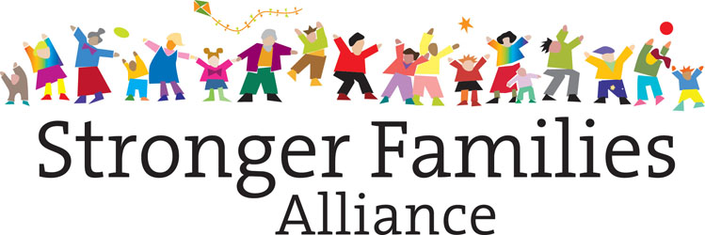

Ownership and collaboration acknowledgement in the SFA
Background:
The Stronger Families Alliance is a unique network that fosters collaboration between Blue Mountains organisations and networks with a stake in early childhood development. The Alliance is guided by emerging international thinking about new ways in which communities, government and business can work together to counter seemingly intractable problems such as rising rates of child abuse and neglect, childhood obesity, the literacy divide and social isolation.
SFA projects result from the collaborative process of the SFA. For this reason the projects involve multiple stakeholders through the project delivery process including (i) need identification and then project (ii) conception (iii) design (iii) resourcing (iv) delivery (v) reporting and (vi) evaluation.
Given the complexity of this context the following document sets out protocols for SFA project partner acknowledgement and legal ownership.
Project acknowledgement:
Principles guiding project acknowledgement protocols
While the SFA creates and launches projects, its primary purpose is to change the interlinked systems that have a causal impact on children’s development. The SFA’s policy draws on research showing that the old adage, it takes a village to raise a child, is empirically correct (Child and Family Plan, page 6). The ‘village’ in this metaphor refers to a collective system of people and households working together, not to the separate actors in the system.
This principle follows through to the processes the SFA uses to create conditions for the success of its growth, projects and initiatives. The experience of the SFA network and research about multi-organisational collaborative networks highlights the following core conditions for success in the collaborative network context (i) the network membership’s awareness that process and project outcomes have been made possible directly and indirectly by multiple people and organisations (ii) the membership’s ability to mutually share, collaboratively lead and promote the network and its project outcomes.

Acknowledgement practice protocols
Given the above, the SFA has agreed to the following practices in relation to SFA project acknowledgement:
(1.) In the context of project acknowledgement the word ownership refers to SFA core member’s rights to take credit for all SFA initiatives and projects, particularly in their promotion to each member’s stakeholder group. (To see a definition of SFA core member see SFA protocol, “Membership structure”).
(2.) The legal lead agency is acknowledged by all SFA core members in the promotion of the SFA project (See ‘Legal ownership’ below for a definition of SFA project legal owners)
(3.) The project lead is responsible for acknowledging the SFA and direct collaborators to the project who contributed significant time, resources or funding without which the project would not be possible.
(4.) The direct project collaborators are responsible for acknowledging the project lead and the SFA.
(5.) In written promotion about specific SFA projects, the collective SFA group is represented by the SFA logo, the lead is acknowledged by its organizational logo and the direct collaborators by their individual logo. Each of the above logos should equally share size and prominence.
(6.) In written promotion about specific SFA projects there needs to be specific and clear acknowledgement of the project’s lead agency.
SFA Project / Initiative Legal Ownership

The SFA is not a legally registered entity. It therefore can’t legally own projects that originate from the SFA collaborative process.

In the context of legal ownership the Lead Agency of the initiative / project owns the initiative / project.

The following process is used to determine the legal lead agency:

(1.) The Lead Agency is determined by the agency who holds the major contract and accountability to the funder to deliver the project.

(2.) In cases where several organizations hold contracts to deliver the project:

a. Both agencies can elect to co-own the project
b. Both agencies can elect that one funded agency is the owner

The following process is used to resolve issues that might arise in determining the legal lead agency:
(1.) The SFA Backbone (the Council and Mountains Community Resource Network) facilitates the issue resolution process.
(2.) The Council and Mountains Community Resource Network cannot lead the issue resolution process if the issue involves either the Council or Mountains Community Resource Network or if a significant stakeholder to the project at issue objects to either the Council or MCRN directing the resolution process. In regards to the cases above:
a. If the issue involves MCRN, the Council will facilitate the issue resolution process.
b. If the issue involves the Council, MCRN directs the issue resolution process.
c. If a significant stakeholder to the project at issue objects to either MCRN or the Council directing the issue resolution process, the SFA Executive will appoint and brief someone to facilitate the issue resolution process.
(3.) The SFA Backbone (or other agency facilitating the issue resolution process) will involve the direct collaborators to the project in the decision making process.
(4.) The SFA Executive is briefed on the issue at their standing meeting.
(5.) In rare cases the collaborative project group, including the funded agencies, can elect to make another agency in the group in the project owner. This can only occur if the major funded partner consents.
Rights and Responsibilities of the Lead Agency:
Facilitating project/program agreements between partners
The Lead Agency will facilitate, or engage the SFA backbone to facilitate, a discussion to determine basic agreements between collaborative partners. In particular the discussion will make clear the rights and responsibilities of the Lead Agency in regards to the project’s implementation and their rights and responsibilities in relation to the project group.
Documenting agreements in MOUs
The Lead Agency, in agreement with partners, will document agreements in a formal MOU either supplied by the Lead Agency, the funder for the program, another member of the group or an MOU the group designs together.
Reporting the project to the SFA
The Lead Agency will log the program onto the SFA’s evaluation system using an EAT (Emergent Action Template) and reports against the program to the SFA using this system.

